INSTRUCTIONS TO APPLY FOR STUDENT TEACHING
Fall 2024 or Spring 2025

OPEN APPLICATION PERIOD: October 23, 2023, at 5:00PM – November 23, 2023, at 7:00AM Eastern Time

Applying to student teaching comes in three steps.

- Step #1 – Attend a Student Teaching Application Meeting
- Step #2 – Complete an application in Tk-20 by 7:00 AM Eastern Time November 23, 2023
- Step #3 – Complete an affidavit in my.bsu.edu

Step #2 – Completing Your Application in Tk-20

Begin by logging into your my.bsu.edu account. You will then scroll down to “additional tools.” From there, locate the Tk-20 link and log in. If prompted to enter another Username and Password, this will be the same information as your my.bsu.edu login.

- Go to the Applications tab and click on the Create New Application button.
- Select the application from the drop-down menu 2024-25 Student Teaching Application and click on the green “Next” button.
- Fill in each field keeping in mind that this will be presented to schools as your official application to
student teach in their building.
- Once you have started an application, you have three (3) options:

- Save: Save the application and return at another time to finish and submit it.
- Submit: Submit your application for final review.
- Cancel: Exit without saving or submitting any changes.

Important: If you have not submitted your application, you may go back into it and edit your responses until 7:00AM Eastern Time on Thursday, November 23, 2023. After this date and time, your application will not be accessible, and changes will not be allowed. For example, your living location may change. If that is the case after the deadline, you must contact OTES-CP (otes@bsu.edu) to document those changes in order for us to process the application and secure your student teaching placement.

Helpful Hints:
- Take note of the restrictions on the length of answers for the three questions and the philosophy of education. These are detailed within the Tk-20 application.

- You may wish to compose your answers in a word processing program to use spelling/grammar checks and a character count. The answers can then be copied into the Tk-20 application.

- Please note that the application document submitted in Tk-20 becomes the cover page for placement requests that are sent to school districts. Take the time to present yourself well.

Upon approval in 1-2 weeks, you will receive an e-mail message verifying your eligibility. If you have questions or concerns, please e-mail otes@bsu.edu or visit our office in TC 205.

Step #3 – Completing the Affidavit for Student Teaching through my.bsu.edu

Log into my.bsu.edu. You will be prompted to enter your Ball State Username and Password. This is the same Username and Password you enter anytime you log into any Ball State online system.

- Go to “Get Technology Help” and click on it.
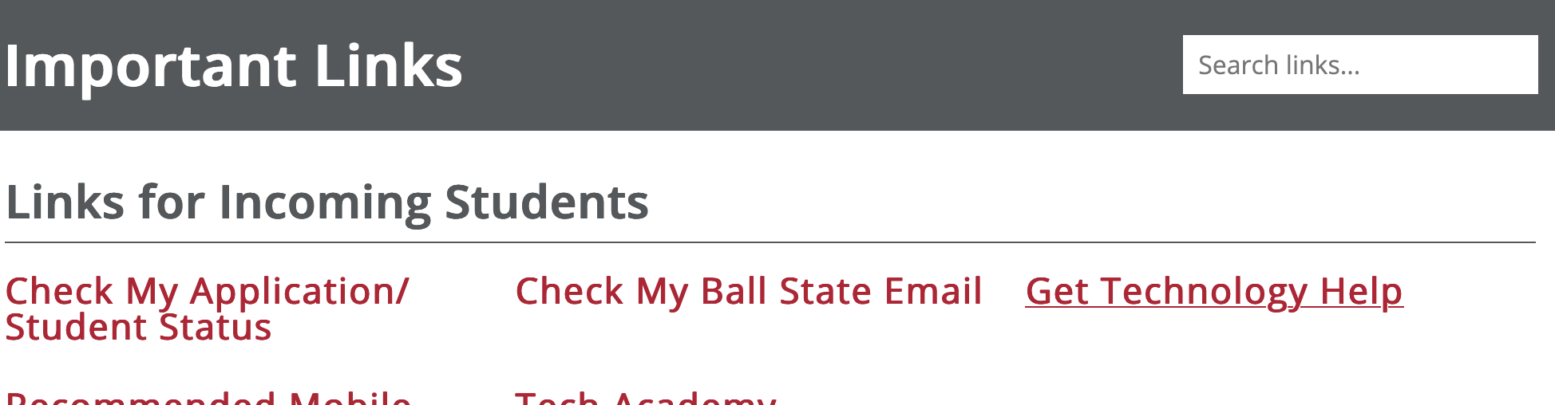

- Select Request Services.
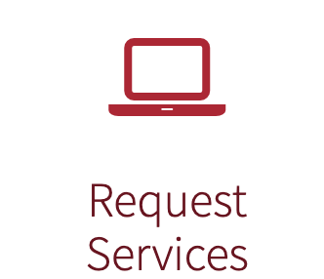

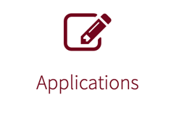
- Select Applications.

- Once you are in the application screen, look for the form titled “Affidavit for Student Teachers.”
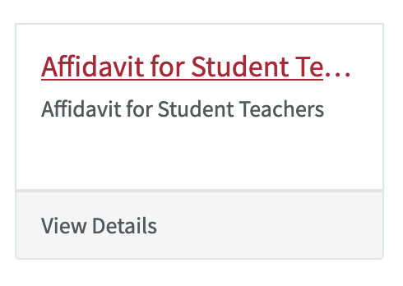

- Fill out the form and officially submit it. Unlike Tk-20, there is no “save” feature with the affidavit. You must either submit the form or come back and redo it at another time.

Helpful Hints:

- If you choose the Grow Your Own (GYO) option, you will need the school information prior to submission of your affidavit. This includes district name, principal’s name, principal’s email address, city and state of district, and grade levels you attended in the district.

- “Additional Information / Special Placements” is a section to put down any requests or special placements you may want. Examples may include but are not limited to “ELED student teacher also obtaining a middle school math license”, “Early Childhood candidate who prefers pre-K over K-3”, or “Secondary candidate who prefers high school over middle school.”

- Please note the completed affidavit and separate completed application are both required for us to consider your student teaching request.

If you have questions or concerns, please e-mail otes@bsu.edu or visit our office in TC 205.

