Study title  Phone or email | Study title  Phone or email | Study title  Phone or email | Study title  Phone or email | Study title  Phone or email | Study title  Phone or email
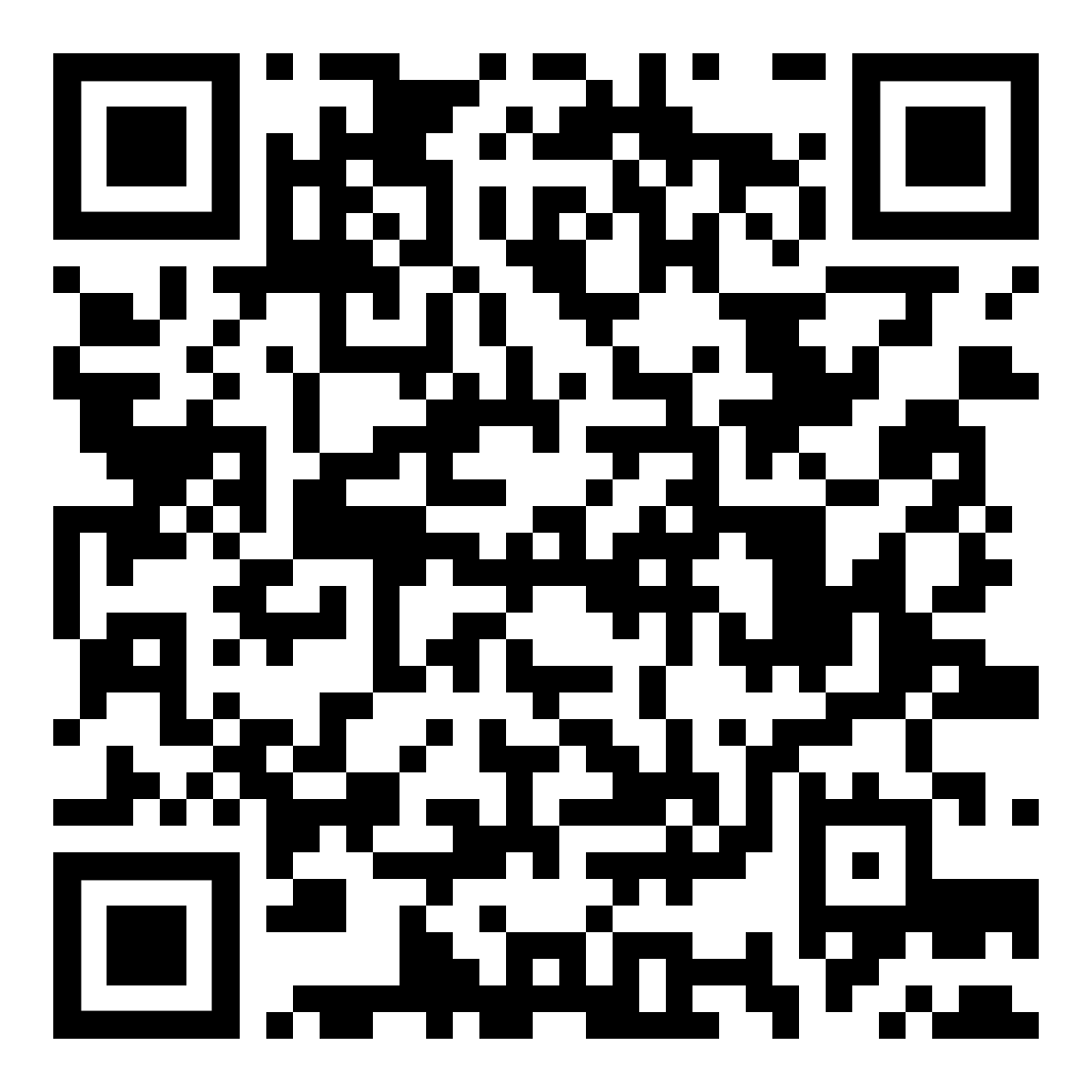
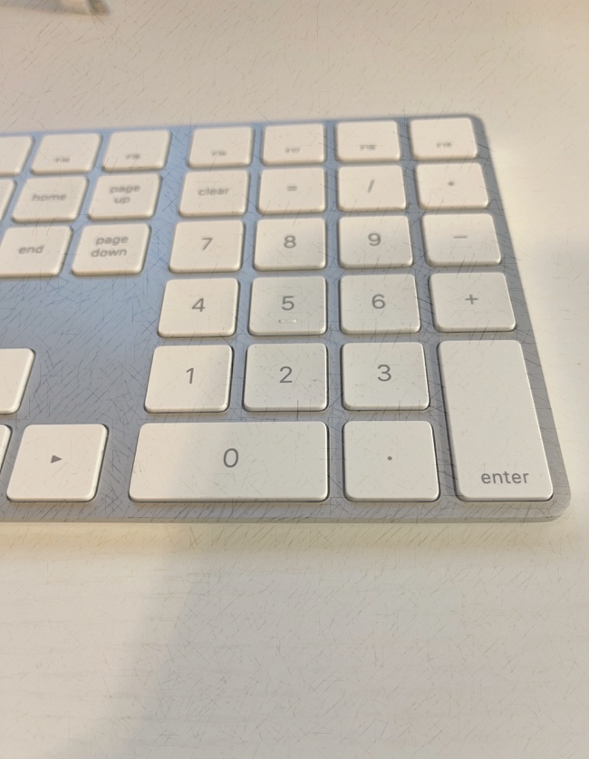
Date last updated: September 16, 2022
You can consider using tear-away tabs. Be certain to add the study title and contact information.
Do not bold or underline compensation. The visual effects used for compensation should be equivalent or lesser than the font size or visual effects of the rest of the page.

You can add a brief headline that grabs attention here.
Do not add compensation information to the headline.

Summary of the study (Study purpose and procedures)

Talk about the main purpose and what you seek to achieve. Remember to keep the language simple and easy to understand.

You must briefly explain what participants will do (e.g., survey/ interview/physical activities, duration of participation, nature of interview/ survey, etc.)

You may want to add risk and benefits, if necessary.

Inclusion/Exclusion Criteria

Add inclusion/exclusion criteria to the flyer if your study requires a target population.

Compensation (if applicable)
Participants will receive:
- Compensation information
(e.g., extra credits, gift card, etc.)
- Snacks or refreshments

Other information
- You may want to include other information that participants should know. For example, the location and length, number of visits, etc.

You can consider using adding QR code for participants to access the website.
Insert the title of the study to allow potential participants to know the topic in advance. The title should be same as the title in your application.
This study was approved by the BSU IRB (IRB number#).
The IRB must review the final copy of printed flyer or online version. Therefore, all image or visual effects should be the final version.
Contact Information
- Name of contact and credentials
- Position, Affiliation, Department
- Ball State University
- emailaddress@bsu.edu
- Phone number
* This is intended to be a guidance to assist researchers create recruitment materials acceptable to the IRB. This is not meant to be a template or design requirement.
Research Study Participants Needed
[Insert Study Title with the IRB number]

