ResearchMatch
Researcher Instructions and Templates

ResearchMatch.org is a national online recruitment tool for health research, funded by the National Institutes of Health and maintained at Vanderbilt University. ResearchMatch connects health researchers with individuals interested in volunteering, through its secure online matching tool. BSU is part of the ResearchMatch Network. There is no cost to BSU researchers to use ResearchMatch. There are currently over 150,000 registered volunteers across the country. ResearchMatch is also now available in Spanish.

How to register

The first step to using ResearchMatch is to register as a researcher.

- Visit ResearchMatch.org and click on the RESEARCHERS tab on the top bar.
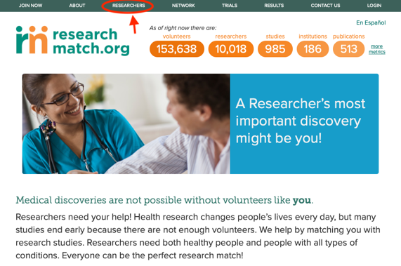

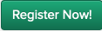
- Click

- Select BSU as your institution, enter your BSU email, and complete the contact and registration information.
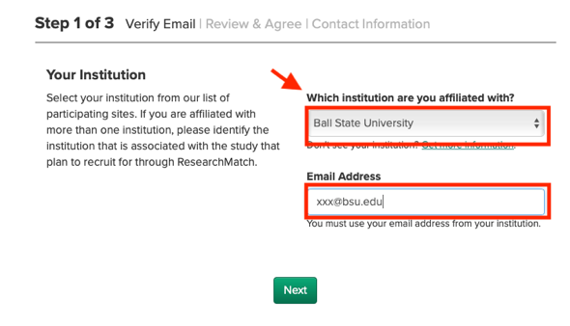
Note: (1) You must use BSU email(xxx@bsu.edu) to register as a researcher.
(2) You do not need to be a Principal Investigator to register.

- When finished, you will be granted “feasibility access” to view aggregate data regarding the current ResearchMatch volunteer population. You will be able to see the demographic and health information breakdown for the volunteers within a designated geographic area.

IRB approval for the use of ResearchMatch for recruitment

If you want to use ResearchMatch for recruitment, your study must be approved by the BSU IRB.

- If you want to use ResearchMatch for recruitment, include the following information within your application (under the recruitment procedures section) or upload a word document containing the request language. If you are adding the use of ResearchMatch to an already IRB-approved study, submit a modification with a word document containing the request language.

Template Language for IRB Submission

I am requesting IRB approval to send the following study recruitment message to potential study volunteers through ResearchMatch.org. ResearchMatch asks me to confirm that this language has been IRB approved and that my direct study contact information has been removed (email/phone) before sending my study announcement through ResearchMatch to volunteers that appear to be a good match for my study.

- When submitting the application, you also need to upload the study- specific recruitment that will be used for the ResearchMatch System.

Rules for ResearchMatch Advertisement (Contact Message)

- Unlike an email, this recruitment message cannot include study team identifiers or contact information (like emails or phone numbers).
- Do not include embedded surveys or URLs.
- The maximum length is 2000 characters.
- This content must also be approved by your institutional IRB.

- BSU IRB will review and approve your initial submission or protocol modification once all requested clarifications are addressed.

- Once the IRB approves your study and the BSU liaison verifies the expiration date in the ResearchMatch system, you will be able to move forward with requesting recruitment access in the ResearchMatch site.

- Access Expiration: A researcher’s access to recruit via ResearchMatch will last only as long as the study’s IRB approval. Researchers are required to submit current IRB-approval letters following each continuing review for the lifetime of the study. If an unintentional lapse in approval occurs and the researcher is not able to submit continuing review approval to ResearchMatch, their ResearchMatch data will not be deleted, but they will not have access to search the registry for recruitment purposes or contact new volunteers until they have uploaded a current IRB approval letter which is once again routed for Institutional Liaison review.

Example Contact Message

Sample 1
Would you like to help researchers learn more about the causes of motor neuron diseases such as ALS and SMA?

Are you interested in helping researchers who are trying to learn more about the causes of motor neuron diseases such as ALS (Lou Gehrig’s disease) and SMA? Researchers at Vanderbilt are looking for study volunteers.

You may be eligible for this study if:
- You are 18 years or older.
- You are a healthy volunteer OR if a physician has determined that you have ALS, SMA or another disorder affecting the motor neuron or nerve.
- You are available for one visit for approximately 1 hour.
- You are willing to have a small biopsy of skin taken from a small spot on your leg.

The skin around the spot will be numbed prior to the sample being taken. The skin biopsy procedure is a standard technique used to look at nerve fibers in the skin. For this study, the researchers will use the skin cells from the biopsy to grow a lot of skin cells (called a culture) and these will be converted to nerve cells.

If you are interested in hearing more about this study, please click “yes” so that a study team member may contact you.

A research team with X UNIVERSITY in CITY, STATE, believes you might be good match for the following study:

If you are interested in this study and having the research team contact you directly, please select the "Yes, I'm interested" link below. By clicking the "Yes, I'm interested" link, your contact information will be released to the research team. If you select the "No, thanks." link or do not respond to this study message, your contact information will not be released to the research team.

QUICK LINK OPTION: YES QUICK LINK OPTION: NO

Sample2
The XXXXX XXXXXXXXXXXX Study
This study looks at how personal and family medical history, lifestyle, and genetics affect a person’s risk for common diseases and response to prescription medications. Study participants will receive information about their personalized risk for many conditions including diabetes, obesity, rheumatoid arthritis, and many different cancers at no cost. Genetic counseling will also be available to participants of this study.
You may be eligible for this study if you:
- Are 18 or older.
- Have a diagnosis of high blood pressure (hypertension) or congestive heart failure.
- Have a valid, private email address.
- Are willing to provide a saliva sample for genetic testing.
- Are willing to complete online health questionnaires and periodic follow-up surveys.
- Are willing to attend a one-hour information/enrollment visit to learn more about the study and provide informed consent.
Compensation is provided upon study completion.
If you or someone you know are interested in hearing more about this study, please consider clicking “yes” so a research team member may contact you to tell you more about the study and answer any questions you may have.

- Potential volunteers will be contacted using the IRB-approved content. Volunteers will then have the option of replying yes or no through a set of quick links available in the notification. If a volunteer chose to respond in the affirmative, they will authorize ResearchMatch to release their contact information to researchers. Researchers will be responsible for managing that information according to institutional guidelines.

Contact and Resources
If you have any questions, please contact us at orihelp@bsu.edu. You can also find more information at Researcher FAQ.

