

Office of Research Integrity
CITI Program User Manual

Updated: August 11, 2022

Table of Contents
Registering 2
Logging In 4
Your Assigned Courses 5
Starting, Continuing, and Completing Your Courses 6
Accessing and Sharing Your Completion Records 6
Linking Your Record to the IRBNet Profile 7
Adding Ball State as Another Affiliation 9

Registering

If you are new to CITI Program, you need to register (create) a new account, which will include creating a CITI username and password.
- To register a new account, visit www.citiprogram.org.
- Click Register in the top right-hand corner.


- Select Ball State University as the "Participating Institutions." Then, click the Continue to Create your CITI Program account.
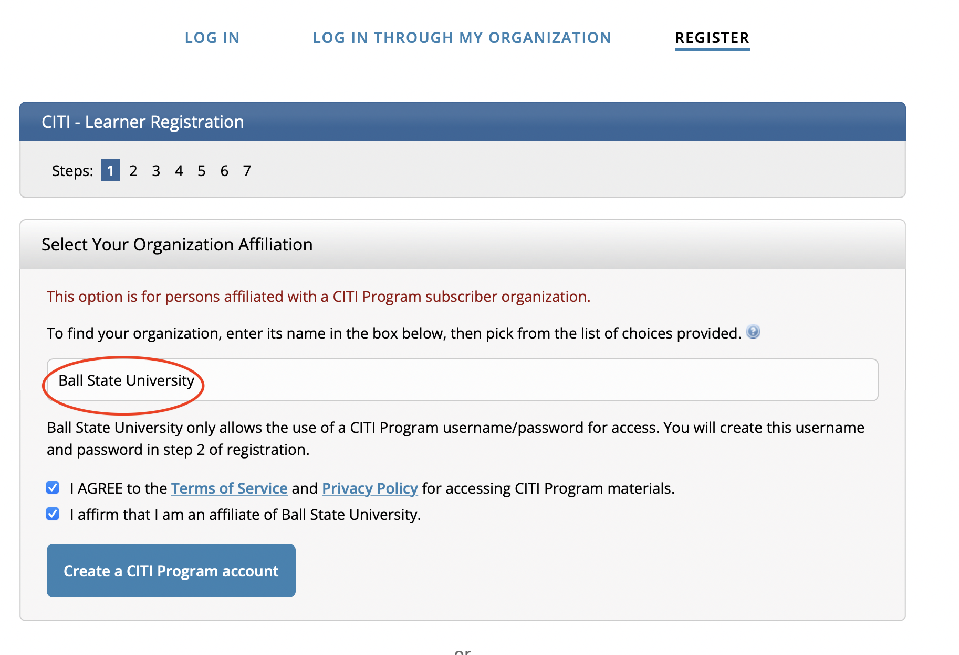

- Complete the registrations steps.
- Step 2,3: Creating log in credentials
- Step 4: Selecting Country
- Step 5: Continuing Education Credit preferences: If you are interested in receiving Continuing Education Unit Credit, click yes.
- Step 6: Providing information requested by your organization for affiliation and reporting purposes.
- Step 7: Selecting your courses offered through your organization. You will choose the curriculum that applies to your research. Outlined on the next few pages are the questions you need answer if you are conducting Human Subjects Research or Animal Research.

Human Subjects Research (IRB):
Only Questions 1 and 5 are required if you are doing Human Subjects Research. You need to choose either Biomedical Research Investigator or Social & Behavioral Research Investigators. You will be able to change your answers to these questions as your research training needs change.
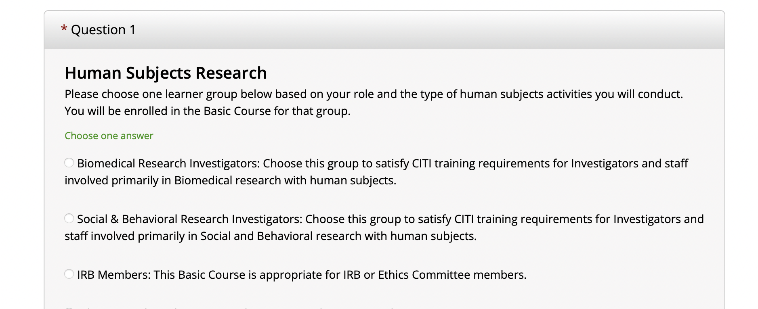

Animal Research (IACUC):
If you are doing research with animals, you must answer questions 1, 2, and 5. You may choose “I do not need to take Human Subjects Research courses at this time” for Question 1. For question 2, please indicate what your role will be and what species you are working with. You will be able to change your answers to these questions as your research training needs change.
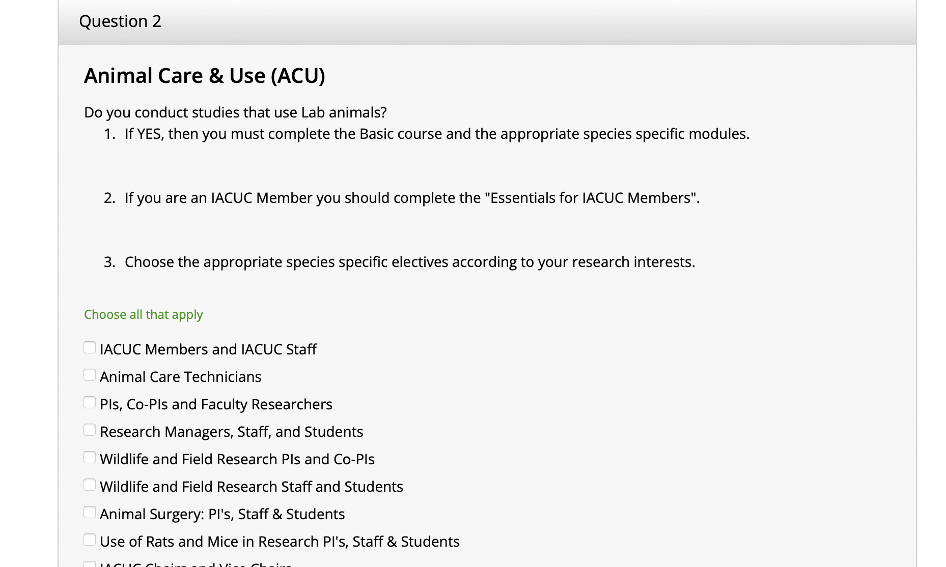
Responsible Conduct of Research (RCR):
If your research is federally funded or a funder requires Responsible Conduct of Research (RCR) training, answer question 3.
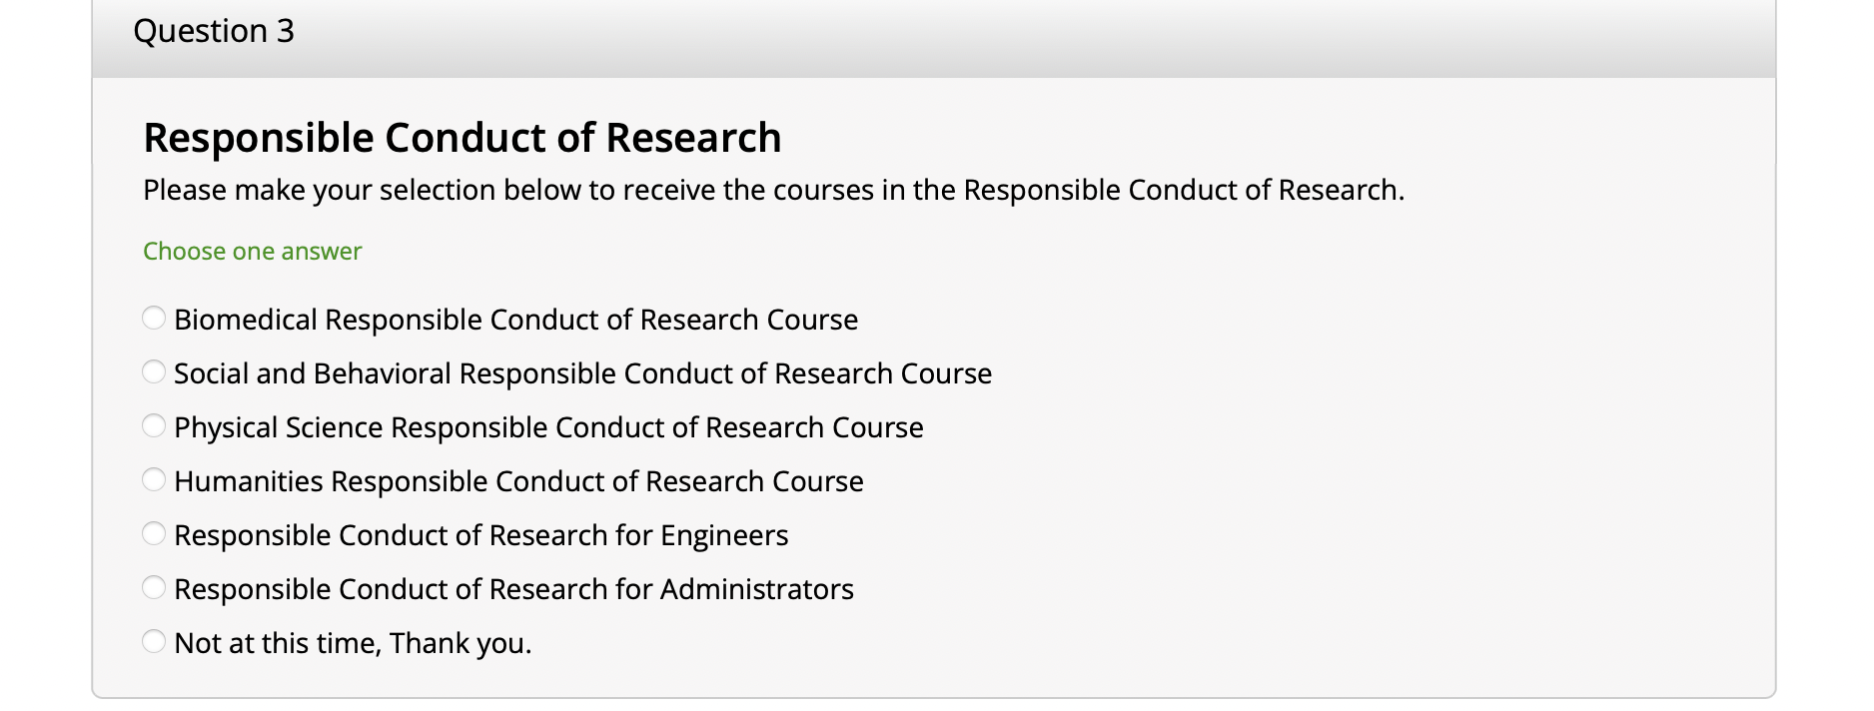
- Once you have answered the applicable questions, click Submit -> Finalize Registration -> Ball State University Courses.

Logging In
Now, you can log in with your username and password. If you have forgotten your CITI Program username or password click on the Forgot links to retrieve your username or reset your password.

Your Assigned Courses

- After logging in, you can see your assigned course by clicking My Courses then click View Courses button next to the affiliation to begin courses.
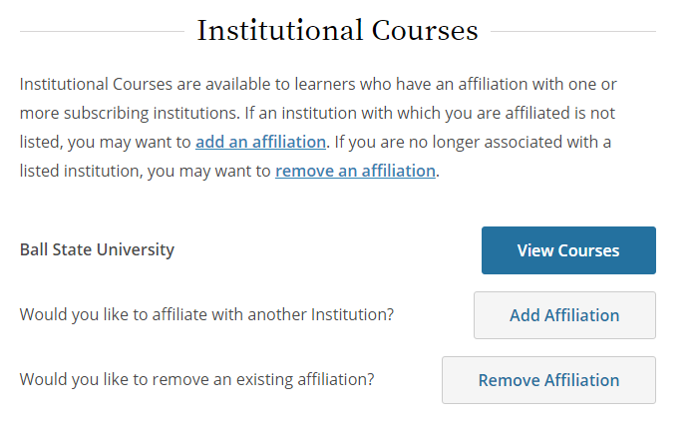

- After you click on the View Courses, you will see a course listing for that institution. The course listing is divided into:

- Active Courses (courses you have started)
- Courses Ready to Begin (not yet started)
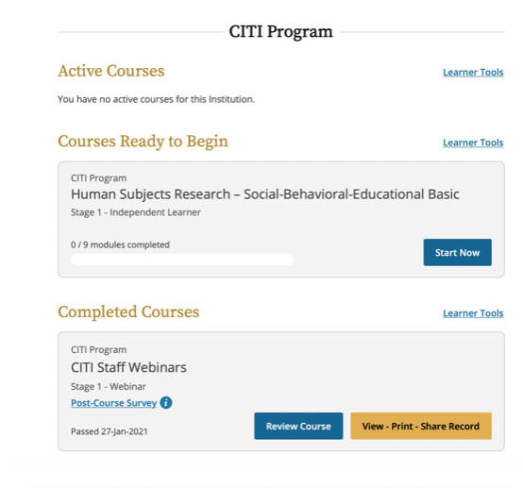
- and Completed Courses

Learner Tools
Learn Tools are available at the bottom of the course page. The Learn Tools provide options designed to help you with tasks for the courses. You can add or remove a course(s), view previously completed coursework, and update or remove the affiliation.
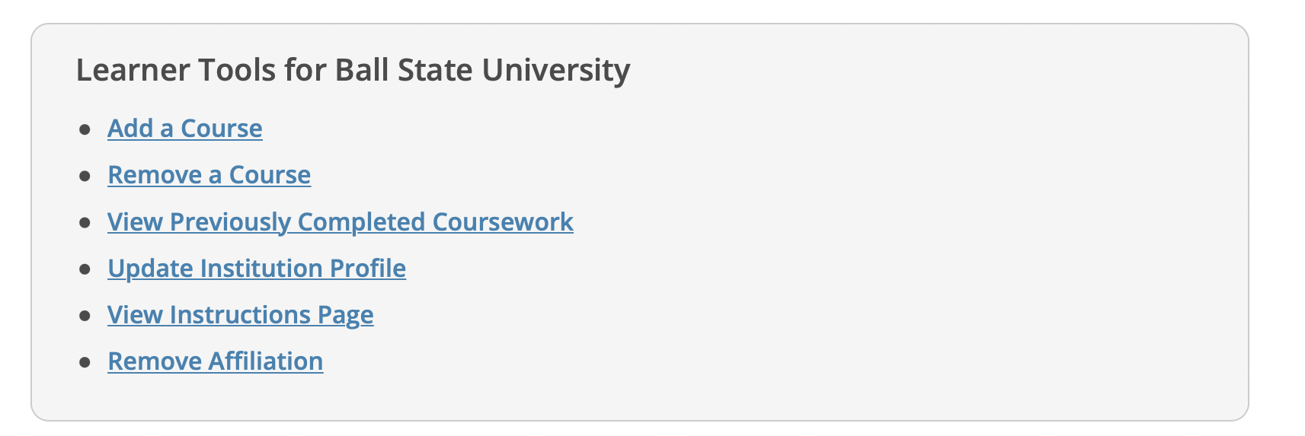

Starting, Continuing, and Completing Your Courses

- Click on the name of each course, reading through it and taking the survey. You must average 80% to earn your completion certificate. Click the Start Now button to begin the course.
- The first time you access a course you must complete the Integrity Assurance Statement. The system will not allow you to start the course modules until you have clicked the "accept" boxes.
- On the Course/Gradebook page you will find:
- Instructions - the number of modules you must complete and the average passing score required to pass the course. These requirements are specific to this institutional course.
- Progress - the number of modules you have completed in the course out of the total number of modules required.
- Score - your current average score. Quiz Scores are calculated by dividing the number of correct answers by the number of the total answers, multiplied by 100.

Accessing and Sharing Your Completion Records
- Under Completed Courses, you can see the list of courses you have completed. Click View – Print – Share Record.

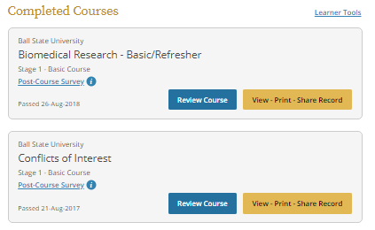
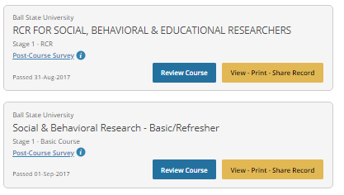

- Click View/Print under the Completion Certificate section to print your certificate from that screen or save it as a PDF if you are going to upload it to IRBNet.

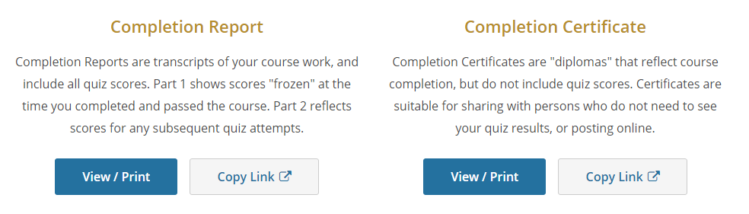
- You can access your completion records through My Records tab which provides the completion records for all course completions on your account. Each records includes;
- Stage - if applicable this list the stage of course such as basic or refresher
- Record ID - a unique number assigned to this completion
- Passing Score - the score required by the institution to pass
- Your Score - the score you achieved to meet passing requirements
- Start Date - the date you started the course
- Completion Date - the date you completed the course
- Expiration Date - if applicable, the date the institution has set for this course to expire
- Gradebook - a link to review the modules in the gradebook or take additional optional modules
- Completion Record - provides access to your completion documents

Linking Your Record to the IRBNet Profile

Linking your CITI certification(s) to your IRBNet account provides easy access to all your CITI records and makes the review process faster. For this reason, we recommend using this method.

- Save the appropriate CITI training certificates to your personal device. You can reference our CITI training user manual for assistance with this process.
  - Contact our office if you have any questions on which trainings are needed for your project.
- Log in to IRBNet.
- Click User Profile in the top right corner of the screen.

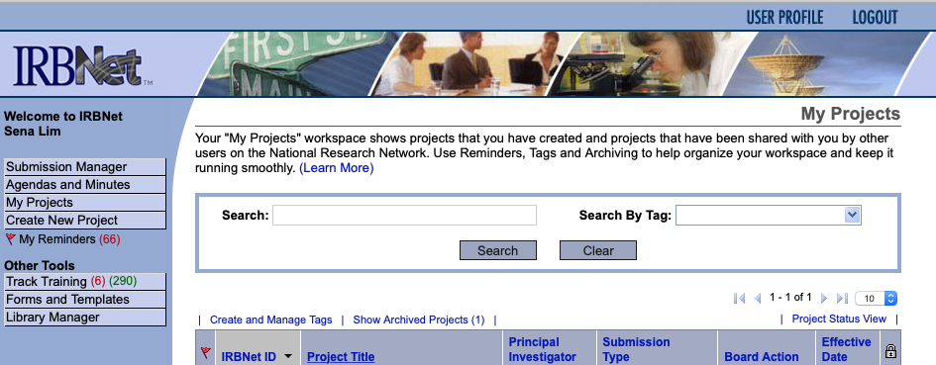

- Scroll down to “Training & Credentials” and click Add a New Training & Credentials Record.
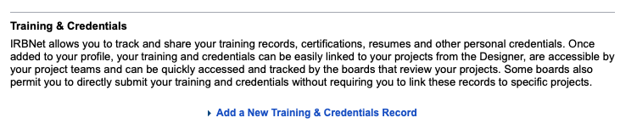
- In the Document Type dop down menu, select the certificate or training you want to upload (e.g., CITI Social & Behavioral Research - Basic/Refresher).

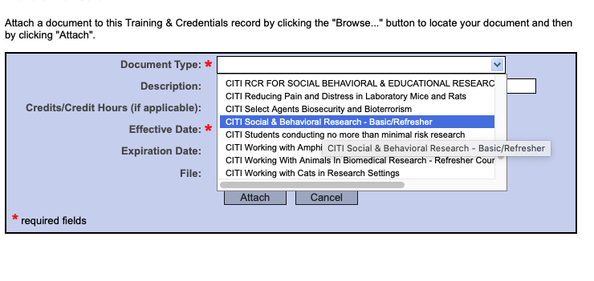

- Enter your Effective Date and Expiration Date, if applicable.
- Click on Choose File and search your computer for your certificate/training file to upload.
- Click on the Attach button.

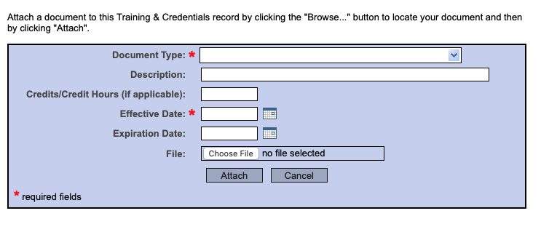

Adding Ball State as Another Affiliation

- On your front page, click Add Affiliation.

- Search for “Ball State University” in the textbox provided. Be sure to check “I AGREE to the Terms of Service for accessing CITI Program Materials” and “I affirm that I am an affiliate of Ball State University”. Then, click “continue”.
Note: this will not remove or undo any preexisting affiliations.
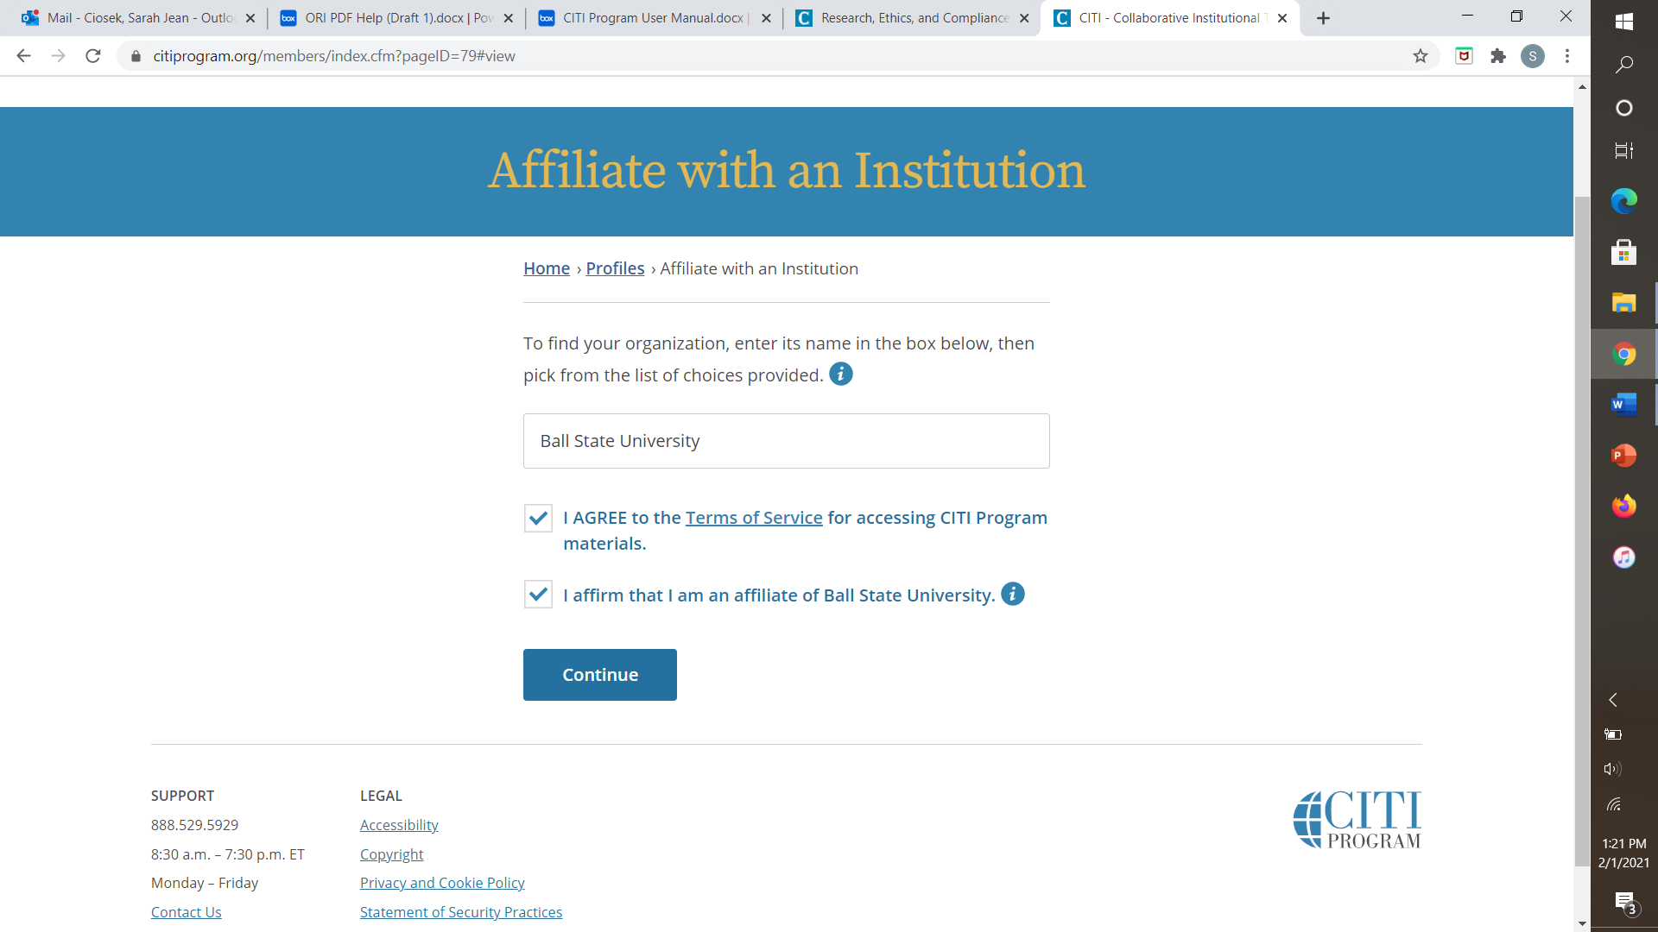

- Provide your information as prompted. Indicate which areas of training you are seeking and click Submit. You should now be affiliated with Ball State.

