Kronos Time Stamp

Specifically For



Nonexempt (Hourly) Employees

in

Workforce Timekeeper 8.0

August 2016

Table of Contents

Table of Contents……………………………………………………….2

Kronos Log On Information……………………………………………3

Kronos Log On Instructions…………………………………………...4

Default Home Screen Information

- Nonexempt (Hourly) Employee…………………………….….5
- Nonexempt Employee with Kronos Manager’s License….…6
  - How to navigate to “My Information”…………………...7

Simple Timestamp Instructions.……………………………………..8-9

Timestamp with Transfers Instructions…………………………….10-13

Add Pay Code Instructions………………………………………….14

Edit Pay Code Instructions………………………………………….15-16

Add Comment or Note Instructions…..…………………………….17-19

Timecard Approval Instructions…………………………………….20

Log Off Instructions………………………………………………….21

In Touch Time Clock Instructions………………………………….22-29

Log On Information

Important Information:

- Kronos 8.0 is JAVA free which means you can use any type of computer (MAC or Window’s PC) and any internet browser (Internet Explorer, Google Chrome, Modzilla FireFox) to log on.

- Kronos 8.0 utilizes single sign on (SSO) which allows you direct access without logging on if you are already logged onto the BSU network.

- Kronos Username and Password are the same as your BSU network account.

Log On Options:

- BSU website/PEB webpage

https://cms.bsu.edu/about/administrativeoffices/payrolleb/payroll/kronos

- BSU website/My.BSU under “Additional Tools”

https://my.bsu.edu/

Please contact the KronosHelpDesk@bsu.edu if you need special accommodations for Kronos or assistance logging on.

Log On Instructions

Log On Instructions:

- Log On Step 1 - Click on one of the links provided above under “Log On Options.”

  - Log on Step 2 - If you are not already logged onto the BSU secure network, you will be taken to the “MY BSU LOGIN” screen and required to enter your BSU username and password.

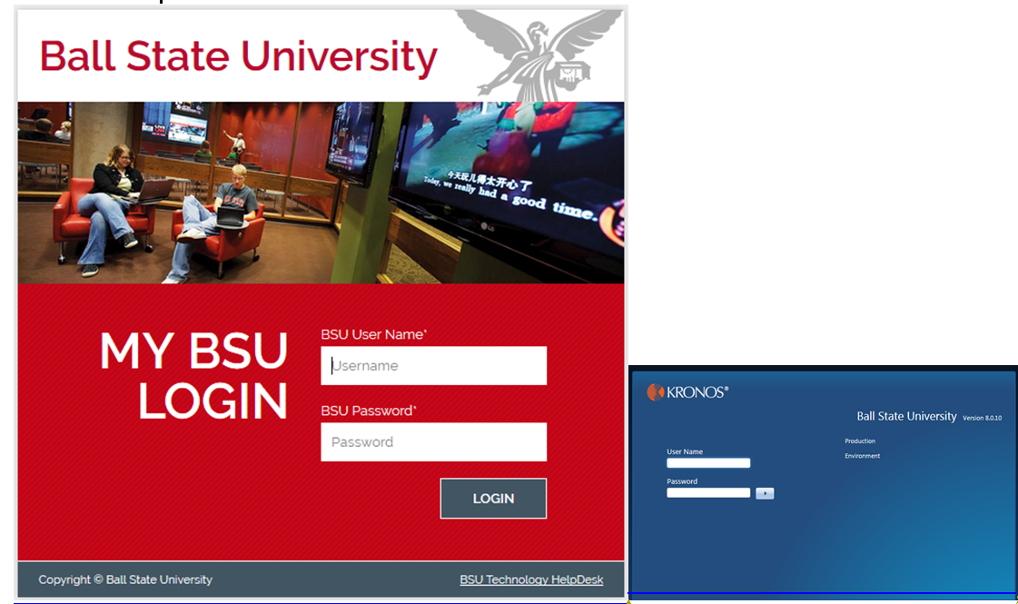

  - If you are already logged onto the BSU secure network, you will be given direct access into Kronos without being required to enter your BSU username and password. This log on feature is called “single sign on” or SSO, it will open Kronos automatically to your default home screen (see example below).

Default Home Screen Information

Default Homepage for Nonexempt (Hourly) Employee:

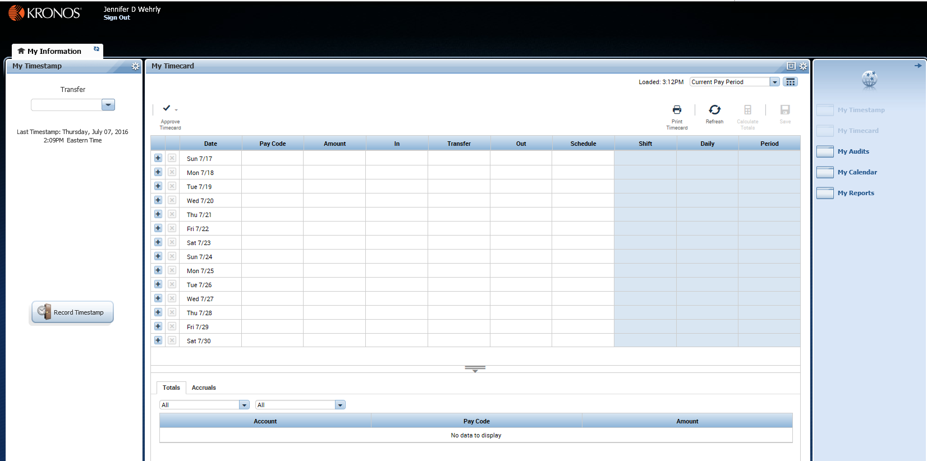

Key Areas of your Default Homepage:

- The upper left-hand corner identifies the system and the employee signed on. It also gives you the link to “Sign Out” or exit the system when you are ready.

- Along the left hand side of the screen is the “My Timestamp” section which allows you to record your Timestamp.

- In the Center of the screen is the “My Timecard”

- Along the right hand side of the screen is your “Related Items” section which allows you to navigate to other related areas in Kronos.

- At the bottom of the screen is a double gray line with a down arrow, this is the hide/show button that allows you to see your totals hours and accruals.
Default Homepage for Nonexempt (Hourly) Employee with a Kronos Manager License:

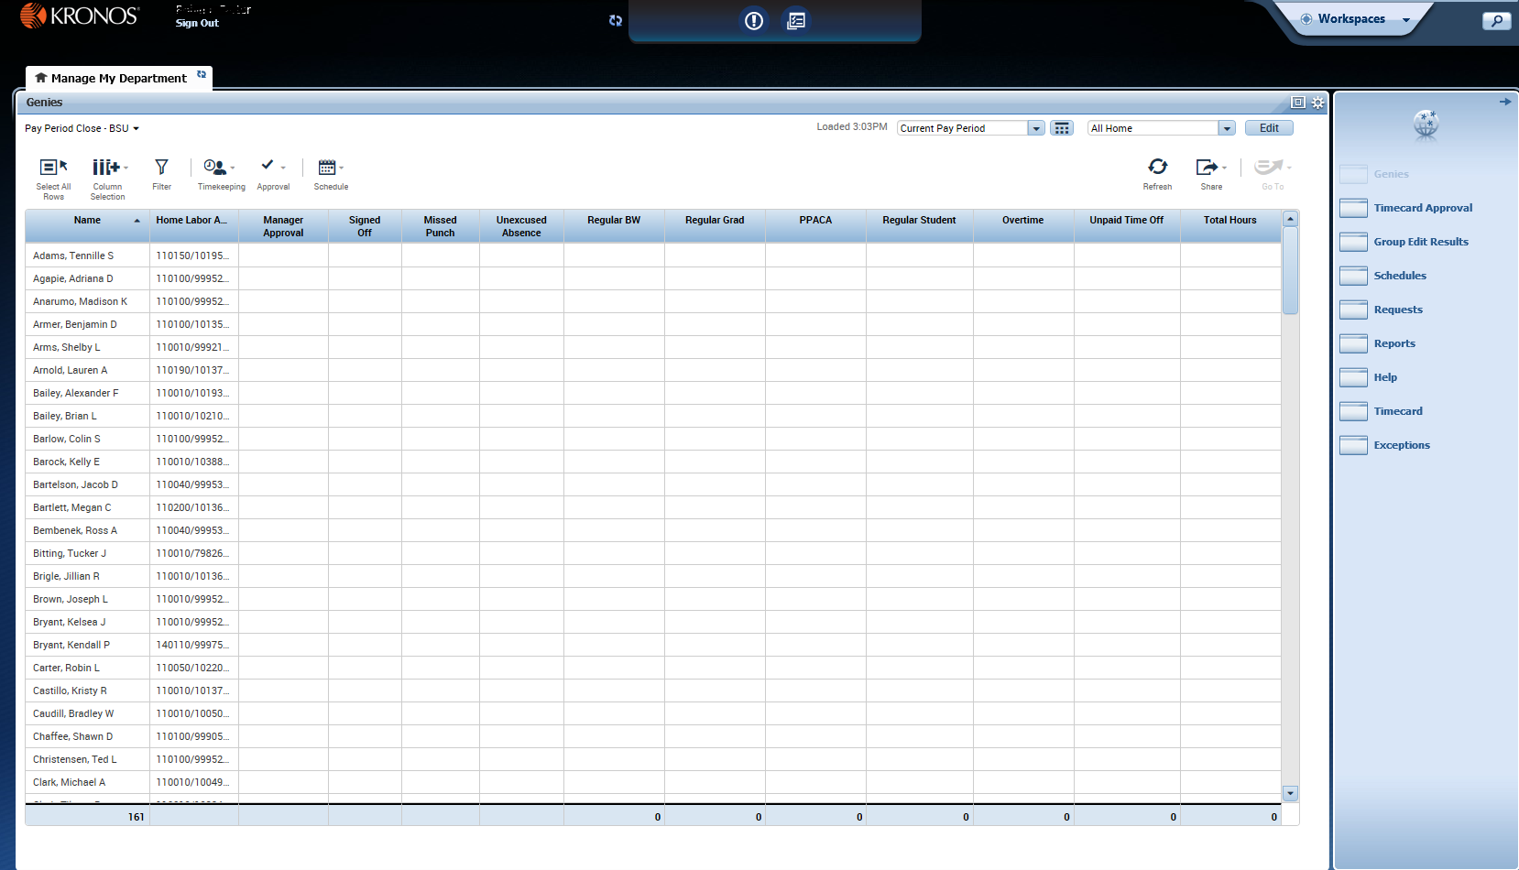

Key Areas of your Default Homepage:

- In the middle of the screen is your primary “workspace.”

- In the upper left-hand corner identifies the system and the employee signed on. It also gives you the link to “Sign Out” or exit the system when you are ready.

- The top center section of the screen allows you to refresh and alerts you to timecard exceptions.

- In the upper right-hand corner is the “carousel” which allows you to change your workspace from “Manage My Department” to “My Information.”

- Along the right hand side of the screen are your “Related Items” section which allows you to navigate to other related areas in Kronos.

How to change your workspace from the “Manage My Department” default homepage to the “My Information” screen:

- My Information Step 1 – In the upper right-hand corner is the “carousel” which allows you to change your workspace from “Manage My Department” to “My Information.” Click on the “Workspaces” drop down menu.



- My Information Step 2 – Scroll through your “carousel” options using the arrows, click on “My Information.”

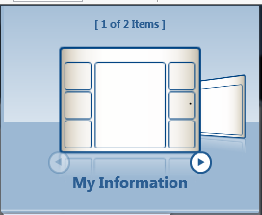

  - A new tab called “My Information” will open in your workspace. My Information contains “My Timestamp” and “My Timecard” information.

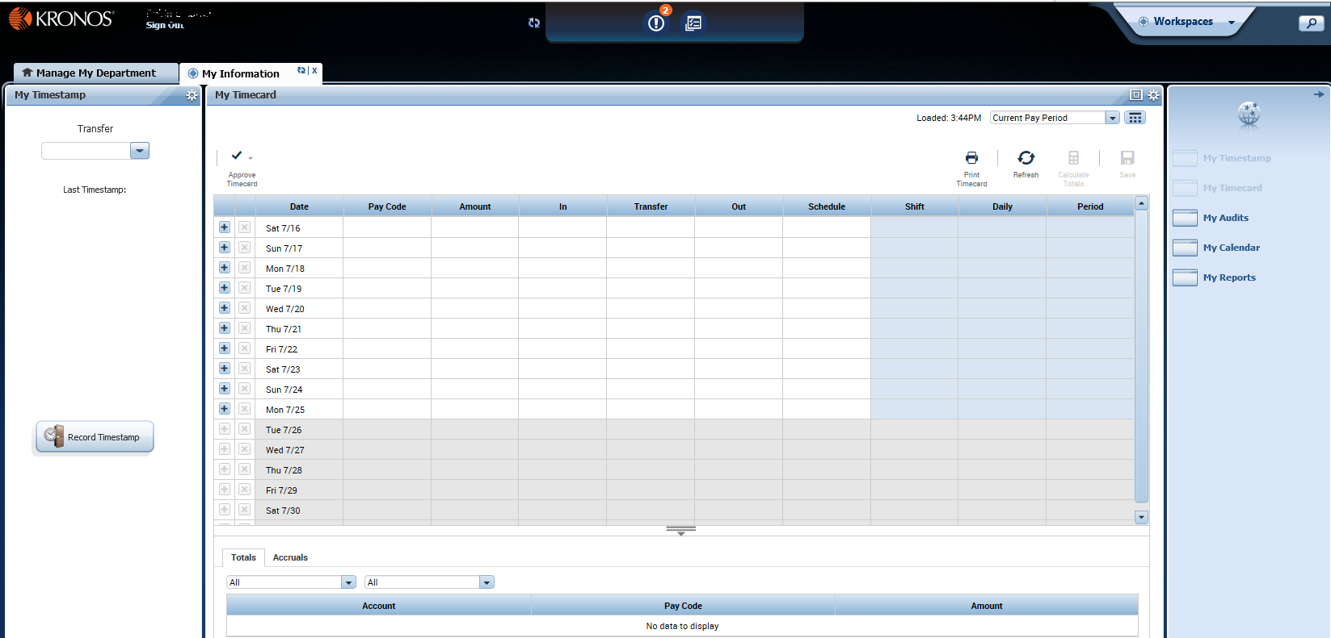

  - When finished with the “My Information” tab, click on the “X.”

Simple Timestamp Instructions

Simple Timestamp Instructions:

- Timestamp Step 1 – From the “My Information” workspace, click “Record Timestamp” along the left hand side of the screen.

- Timestamp Step 2 – After clicking “Record Timestamp,” you will immediately see a confirmation of the time recorded appear just below the “Transfer” menu in “My Timestamp.”

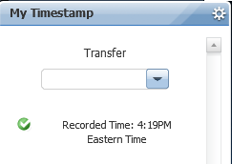

- Timestamp Step 3 (Optional) – After you get the confirmation of time recorded, click on the “refresh” icon located on the “My Timecard” workspace to see your timestamp appear on your timecard.

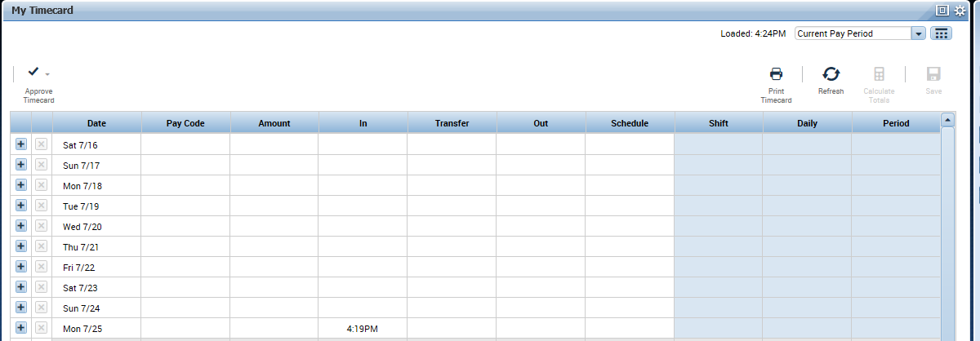

Timestamp with Transfer Instructions

Timestamp with Transfer Instructions:

- Timestamp with Transfer Step 1 – From the “My Information” workspace, click the drop down arrow just below “Transfer.”

- Timestamp with Transfer Step 2 – From the “Transfer” menu, click “Search” and the “Select Transfer” menu will appear.

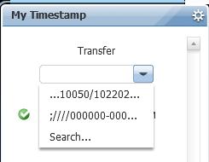

- Timestamp with Transfer Step 3 – Determine whether you are doing a “job transfer” to a secondary position or a “labor transfer” to charge your labor expense to a different labor account. From the “Select Transfer” menu, select the appropriate transfer information and then click “OK.”

Labor Account Levels:

  - Level #1 TS-ORGN-CODE (Timesheet Organization Number)
  - Level #2 EE-POS-SUFF (Employee Position including Suffix)
  - Level #3 ECLS-CODE (Employee Classification Number)
  - Level #4 SUPV-POSN-SUFF (Supervisor Position incl Suffix)
  - Level #5 LABOR-TRANSFER (Fund-Org-Program-Activity)

In order to complete a job transfer, you will need to populate labor account levels #1-4, by selecting the appropriate information from the each drop down menu on each labor level.

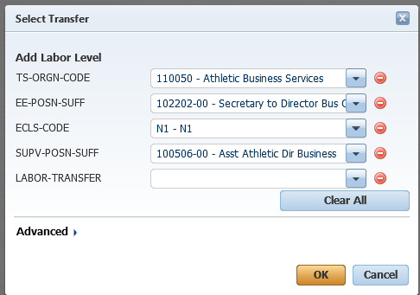

In order to complete a labor transfer, you will need to populate labor account level #5 by selecting the appropriate information from the “labor transfer” drop down menu.

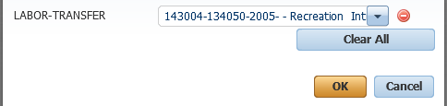
- Timestamp with Transfer Step 4 – From the “My Information” workspace, click “Record Timestamp” along the left hand side of the screen.

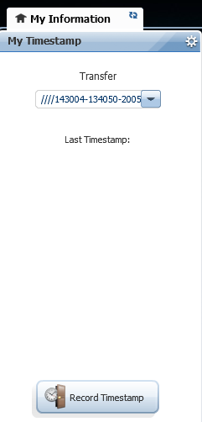

- Timestamp With Transfer Step 5 – After clicking “Record Timestamp,” you will immediately see a confirmation of the time recorded appear just below the “Transfer” menu in “My Timestamp.”

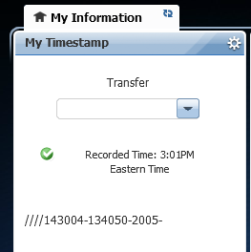

- Timestamp Step 6 (Optional) – After you get the confirmation of time recorded, click on the “refresh” icon located on the “My Timecard” workspace to see your timestamp with transfer appear on your timecard.

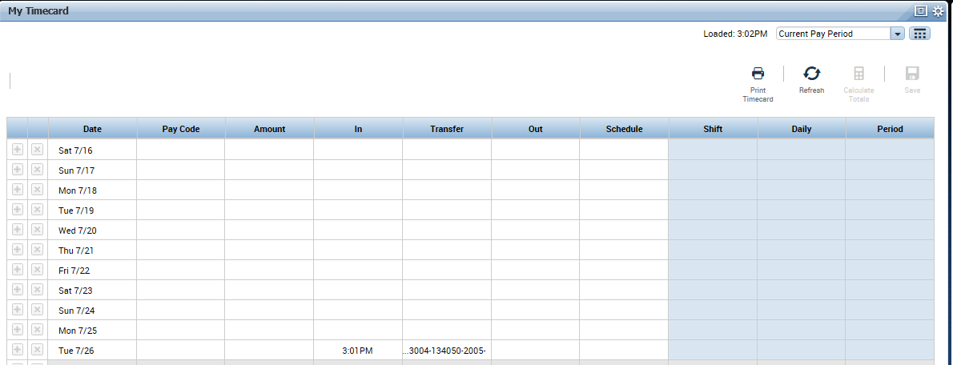

Add Pay Code Instructions

How to enter a Pay Code on a timecard:

- Add Pay Code Step 1 – From “My Timecard,” left click in the “Pay Code” cell next to the date you wish to add the pay code. A drop down list of available pay codes will appear; select the pay code you wish to use from the list.

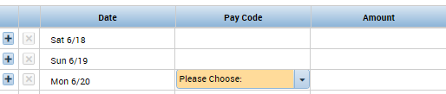

- Add Pay Code Step 2 – Once the pay code is selected, click “tab” to navigate to the “Amount” cell to the right of the pay code field and enter the number of hours used.

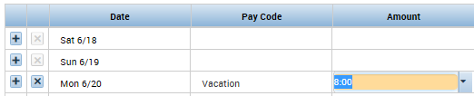

  - Acceptable formats when entering a pay code amount:
    - 8, 08, 8:00 = 8:00 hours
    - 8.5, 8:30 = 8:30 hours

- Add Pay Code Step 3 – Once the pay code amount is entered, click “Save” to save it to the timecard.
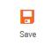

Edit Pay Code Instructions

How to edit a Pay Code on a timecard:

- Edit Pay Code Step 1 – From “My Timecard,” you can edit the pay code or the amount by right clicking in that field next to the date you wish to edit the pay code and the “Pay Code Actions” window will appear.

  - In the example below, the employee had originally requested 8 hours of vacation on 7/01/16. The employee wishes to change their vacation request to only 4 hours on 7/01/16.

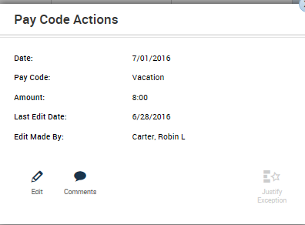

- Edit Pay Code Step 2 – Once the “Pay Code Actions” window appears, click the “Edit” icon and the “Amount” window will appear.

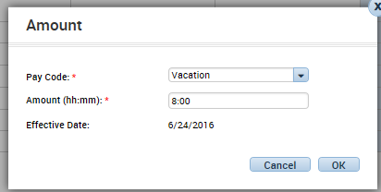

- Edit Pay Code Step 3 – Once the “Amount” window appears, you can change either the “Pay Code” or the “Amount” fields. In this example, you will change the 8 hours to 4 hours and click “OK.”

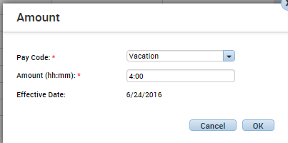

- Edit Pay Code Step 6 – After the “Amount” window disappears, you are taken back to the employee timecard where you should review and save your changes to the pay code amount field, click “Save

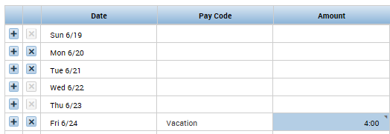



Add a Comment and a Note

Comments and notes are available in Kronos, they can be used to track various information or attach a reminder to a punch or pay code amount. Kronos Workforce Timekeeper allows you to select from a predefined comment list and add a free form note. In order to add a note, you must first select a comment. You can have a comment without a note, but you cannot have a note without a comment. Please use discretion when you enter a note, this information will be visible on reports.

Comment and Note Instructions:

- Add Comment Step 1 – On your timecard, right click in the cell with the punch or pay code amount you want to attach a comment to and the “Punch Actions” or “Pay Code Actions” window will appear.

  - In the example below, you entered 8 hours of vacation on 6/22. You can add a comment and a note to this pay code amount.

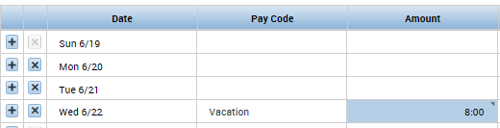

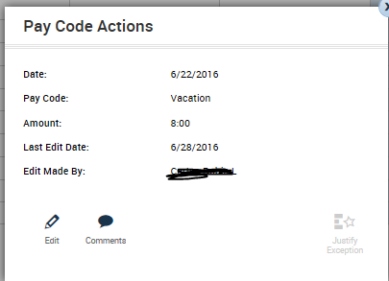
- Add Comment Step 2 – From the “Pay Code Actions” window, click “comment” and the “Comment” window appears.

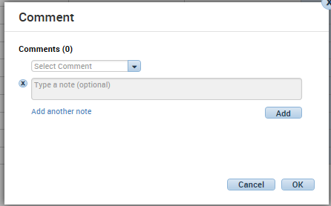

  - Using the drop down menu, select the comment.

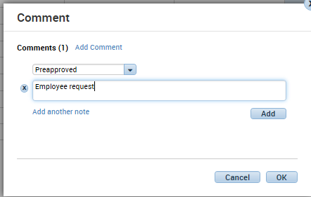

- Add Comment Step 3 – From the “Comment” window, select a predefined comment, enter a note, and click “Add.”

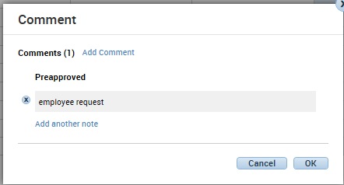
- Add Comment Step 4 – From the “Comment” window, review the comment and note information, then click “OK.”

  - At this point, it also gives you the option to add another comment and/or note if you desire. Click either “Add Comment” or “Add another note.”

- Add Comment Step 5 – After the “Comment” window disappears, you are taken back to the employee timecard where you should save your comments and notes on the pay code amount, click “Save.”
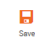
- Add Comment Step 6 – Once your comments and notes are saved on
the pay code amount, you will see a blue speech bubble appear in the cell with the amount.

Timecard Approval Instructions

When you have finished your last shift in the pay period, you can approve you timecard to indicate you have reviewed and approve the hours shown on your timecard.

Timecard Approval Instructions:

- Approval Step 1 - When you have finished your last shift in the pay period, you can approve you timecard to indicate you have reviewed and approve the hours shown on your timecard. From “My Timecard,” you click the “Approve Timecard” icon in the upper left hand corner of your timecard information.

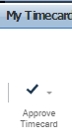

- Approval Step 2 – When the approve timecard menu appears, select “Approve Timecard” to apply your approval.

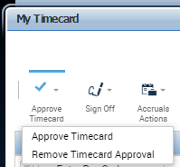

Log Off Instructions

Log Off Instructions:

- Log Off Step 1 - When you are ready to log off of Kronos, simply click on “Sign Out” just below your name in the upper left hand corner of the screen.

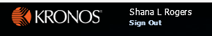

Kronos InTouch Time Clock Instructions


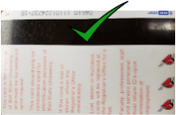
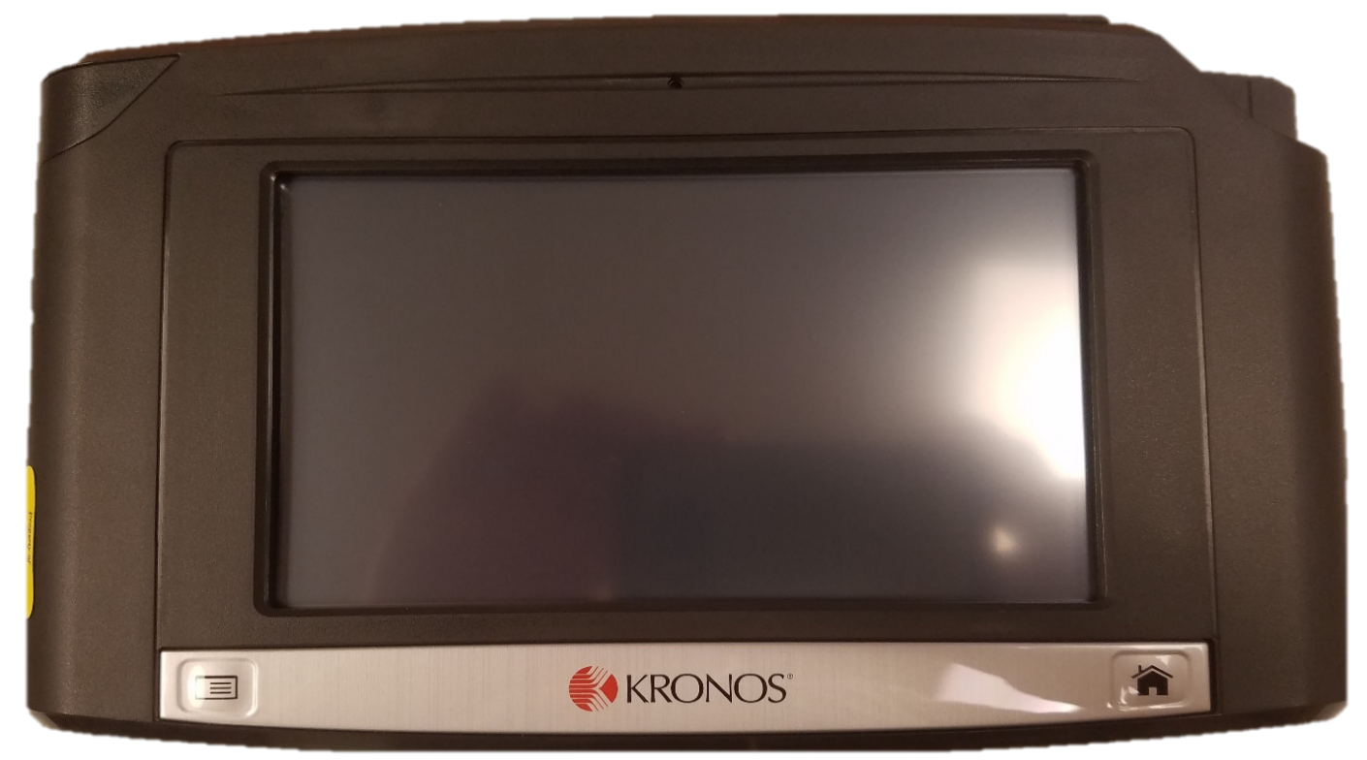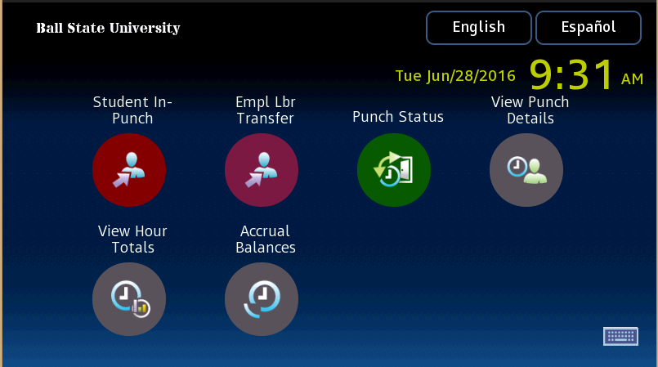
5
4
6
2
7
3
Use this button to return to the Main Menu screen.
This indicator will glow GREEN when a swipe is successful, RED when it fails.
Card reader slot: Use your Cardinal Card (BSU ID) with the magnetic stripe facing the wall.
1
- How to Clock-In (In-Punch)
  - Regular (non-student) employees:

    - Do not select any options from the clock.
    - Swipe your Cardinal Card (BSU ID) through the card reader slot .
      - The new clocks uses the magnetic stripe of your Cardinal Card, not a barcode.
      - Before swiping, the magnetic stripe should face the wall, and fit into the card reader slot.
    - Confirm the indicator light blinked GREEN (or that you heard the successful chime).
    - If the indicator light blinks RED (or you will hear a failed chime), the swipe was unsuccessful.
      - Read the error message that is displayed. Most cases, re-swiping will correct the issue.
      - You are not allowed to swipe more than once within a two minutes period. If you accidentally swipe a second time within the two minute period, you will receive the error “Punch rejected…You are attempting to punch too soon after your previous punch…”. This error can be ignored, since your first punch was already accepted.
      - Please check your Cardinal Card, and verify that the magnetic stripe on your card is not damaged. If there is a scratch through the magnetic stripe (or other damage), you will have to get a new ID.


  - Regular (non-student) employees with a “Labor Transfer”:
    - Press the “Empl Lbr Transfer” option on the clock .
    - Swipe your Cardinal Card (BSU ID) through the card reader slot .
      - The new clocks uses the magnetic stripe of your Cardinal Card, not a barcode.
      - Before swiping, the magnetic stripe should face the wall, and fit into the card reader slot.
    - A list of valid labor accounts (starts with “LT-*”) will be displayed.
(Note: If no list is shown, or an error message is display, then you are not setup to transfer to a different labor account.)
      - Select the labor account from the list.
      - Verify the labor account is correct then press on submit to complete the clock-in process.
      - Confirm the indicator light blinked GREEN (or that you heard the successful chime).
      - If the indicator light blinks RED (or you will hear a failed chime), the swipe was unsuccessful.
        - Read the error message that is displayed. Most cases, re-swiping will correct the issue.
        - You are not allowed to swipe more than once within a two minutes period. If you accidentally swipe a second time within the two minute period, you will receive the error “Punch rejected…You are attempting to punch too soon after your previous punch…”. This error can be ignored, since your first punch was already accepted.
        - Please check your Cardinal Card, and verify that the magnetic stripe on your card is not damaged. If there is a scratch through the magnetic stripe (or other damage), you will have to get a new ID.


  - Student employees:
    - Press the “Student In-Punch” option on the clock .
    - Swipe your Cardinal Card (BSU ID) through the card reader slot .
      - The new clocks uses the magnetic stripe of your Cardinal Card, not a barcode.
      - Before swiping, the magnetic stripe should face the wall, and fit into the card reader slot.
    - A list of active jobs will be displayed.
      - Select the job you are clocking into from the list presented.
      - Verify the job is correct then press on submit to complete the clock-in process.
      - Confirm the indicator light blinked GREEN (or that you heard the successful chime).
      - If the indicator light blinks RED (or you will hear a failed chime), the swipe was unsuccessful.
        - Read the error message that is displayed. Most cases, re-swiping will correct the issue.
        - You are not allowed to swipe more than once within a two minutes period. If you accidentally swipe a second time within the two minute period, you will receive the error “Punch rejected…You are attempting to punch too soon after your previous punch…”. This error can be ignored, since your first punch was already accepted.
        - Please check your Cardinal Card, and verify that the magnetic stripe on your card is not damaged. If there is a scratch through the magnetic stripe (or other damage), you will have to get a new ID.

- How to Clock-Out (Out-Punch) – ALL EMPLOYEES:
  - Do not select any options from the clock.
  - Swipe your BSU ID through the card reader slot .
  - Did you see the indicator light blink GREEN and/or hear a successful chime?

- The InTouch Clocks are touch-screen enabled devices that allows employees to perform various time-keeping functions:

  - “Student In-Punch”
    - Students should ALWAYS select this option for when clocking-in (In-Punch).
    - Only used for In-Punches. Do not select this option for clocking-out (Out-Punch).
    - Once selected, student will swipe their ID, and a list of active jobs for that student will be displayed.
    - Below the list of active jobs is a list of Labor transfers “LT-*”
      - Only available for student employees with a Primary job assignment in Dining, Housing and Rec Services.
      - Labor transfer allows a student employee to work their Primary job, but charge the labor to a different account (FOAPAL).
      - Only works with student’s Primary job assignment.
      - Will not be available for Federal Work Study jobs.
      - The list of Labor transfer will start with “LT-*”
      - Once selected, the time will be charged to that FOAPAL until the student clocks-out.

  - Employee Labor Transfer (Empl Lbr Transfer)
    - Currently used only for Dining, Housing and Rec Services.
    - Labor transfer allows an employee to work their Primary job, but charge the labor to a different account (FOAPAL).
    - Only works with employee’s Primary job assignment.
    - The list of Labor transfer will start with “LT-*”
    - Once selected, the time will be charged to that FOAPAL until the Employee clocks-out.
    - Once selected, an employee will swipe their ID, and a list of valid labor transfer options “LT-*” will be displayed.
      - This list is specific to an employee, based on the employee type, and their time-sheet organization.
      - Only available for employees with a Primary job assignment in Dining, Housing and Rec Services.
    - Only used for In-Punches. Do not select this option for clocking-out (Out-Punches).


  - Punch Status
    - To use – Press “Punch Status” and swipe your ID Card.
    - Will show last date and time of a punch on this specific clock.
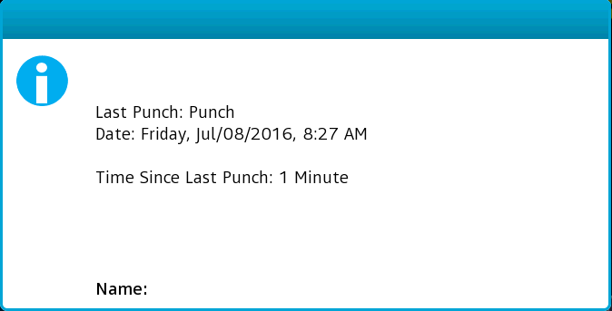
    - Will only show punches made on the same clock.


  - View Punch Details
    - Shows your timecard details.
    - Will show time entered from all sources.
    - Allows you to select a Time Period.
    - This function is only available during non-busy hours:
      - Monday thru Friday between
        - 8:10am and 3:20pm
        - After 5:10pm
      - All day Saturday and Sunday
    - To use:
      - Press “Punch Status” and swipe your ID Card.
      - Select the “Time Period”
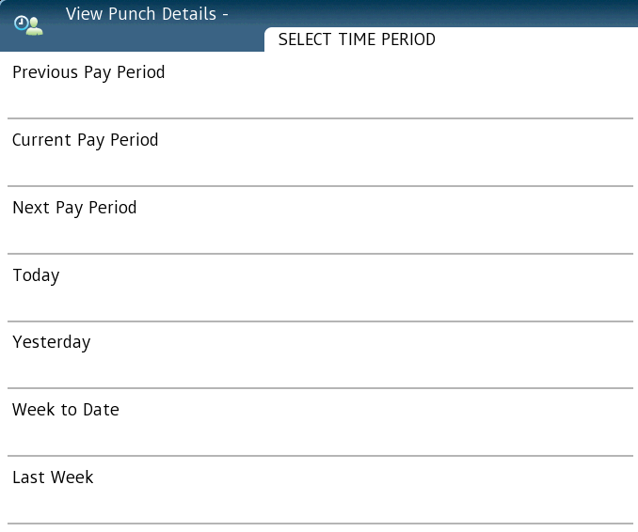
      - After selecting a time Period, you will see a calendar with daily totals. The symbols indicates possible issues with your existing timecard (refer to Thu (6/30 and Fri (7/1) below).
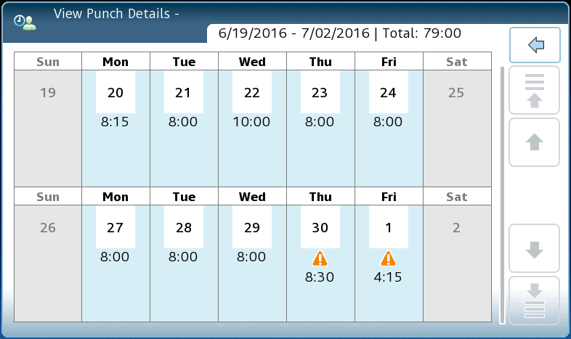

      - To see the details of a particular day, and to view a description of the issues ( ), select the day from the clock), then scroll down the list to the day in question.
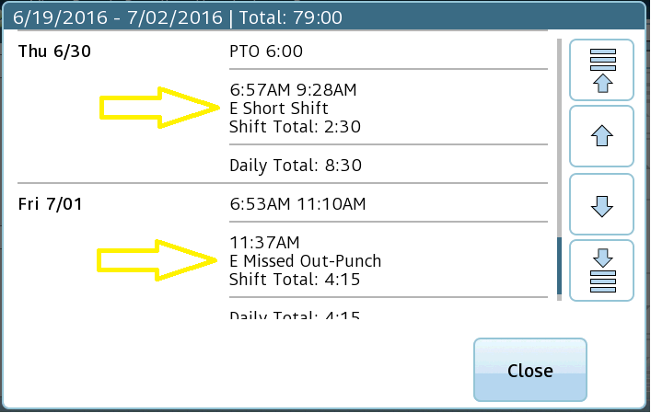

      - Once you are done viewing your Time Card details, press the “Home” button located on the bottom right of the clock.
      - The screen will automatically log you out after about 30 seconds of inactivity.


  - View Hour Totals
    - Shows hours totals by position/labor levels.
    - Will show time entered from all sources.
    - Allows you to select a Time Period.
    - This function is only available during non-busy hours:
      - Monday thru Friday between
        - 8:10am and 3:20pm
        - After 5:10pm
      - All day Saturday and Sunday
    - To use:
      - Press “View Hour Totals” and swipe your ID Card.
      - Select the “Time Period”

      - After selecting a time period, a list by labor levels showing totals hours will be displayed.
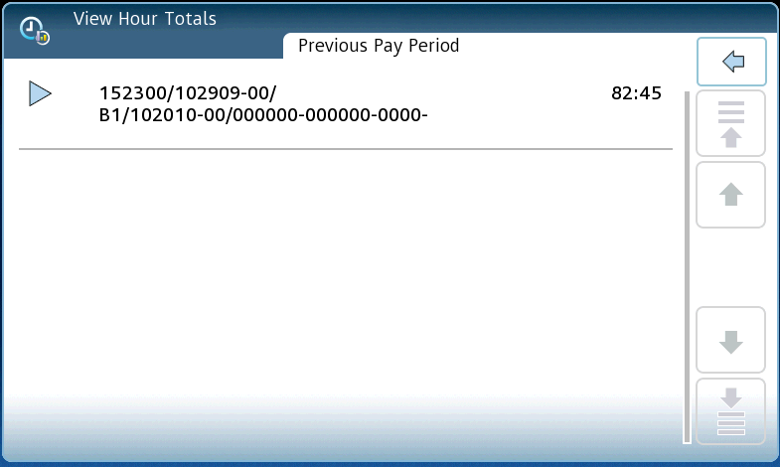
      - Once you are done viewing your hour totals, press the “Home” button located on the bottom right of the clock.
      - The screen will automatically log you out after about 30 seconds of inactivity.


  - Accrual Balances
    - Shows accrual balances for a specific selected date.
    - Only available for employees that have accruals.
    - This function is only available during non-busy hours:
      - Monday thru Friday between
        - 8:10am and 3:20pm
        - After 5:10pm
      - All day Saturday and Sunday
    - To use:
      - Press “Accrual Balances” and swipe your ID Card.
      - Select the day from the calendar displayed.
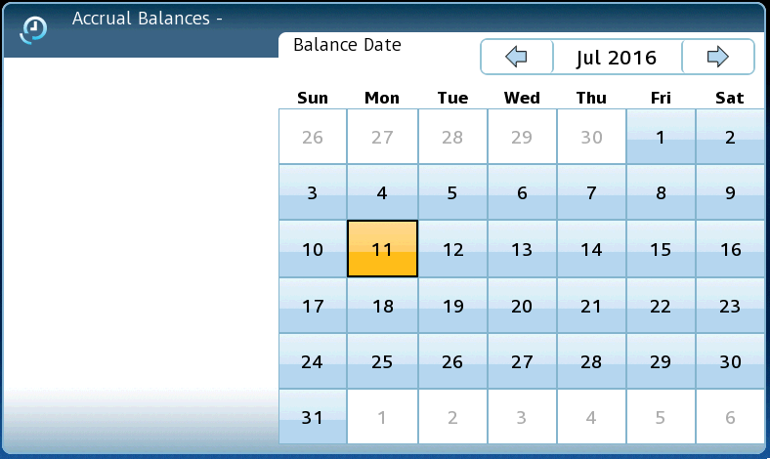

      - After selecting the as of the date, a listing of all your accruals along with the balance will be displayed.
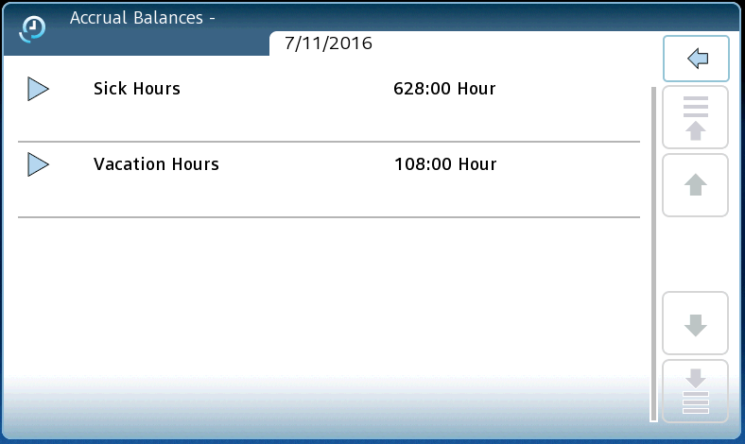
      - Once you are done viewing your accrual balances, press the “Home” button located on the bottom right of the clock.
      - The screen will automatically log you out after about 30 seconds of inactivity.

