Placing Mediasite Videos in Canvas

- Go into the course where you want to place a link to your video.

- If needed, create a Module by clicking the Add Module button.
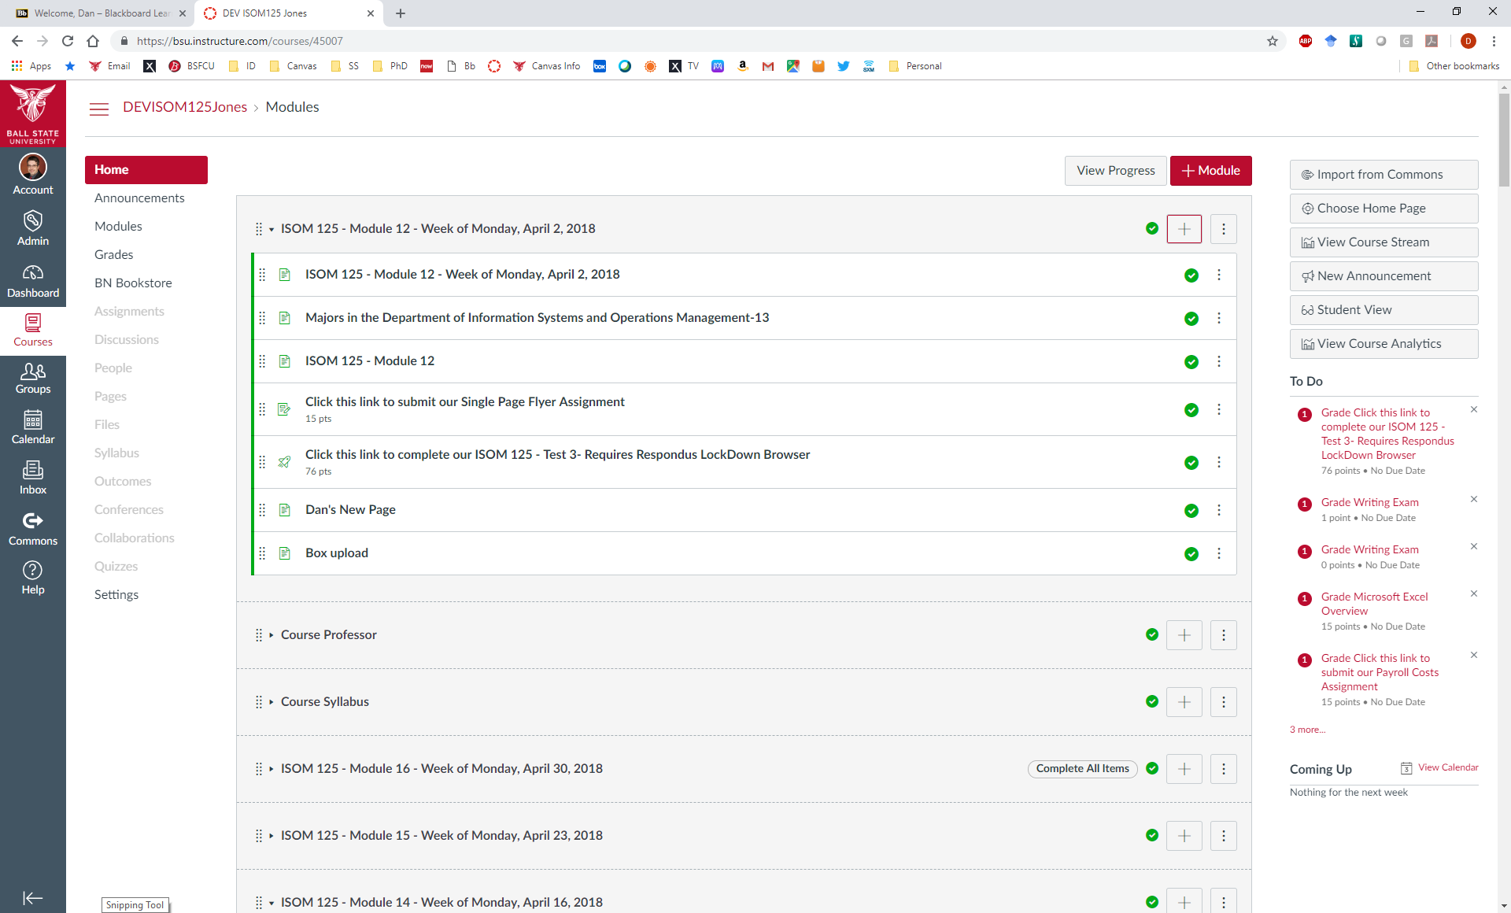

- Click the Add Item button for the proper Module.

- Select Page, New Page, give the page a name, and click the Add Item button
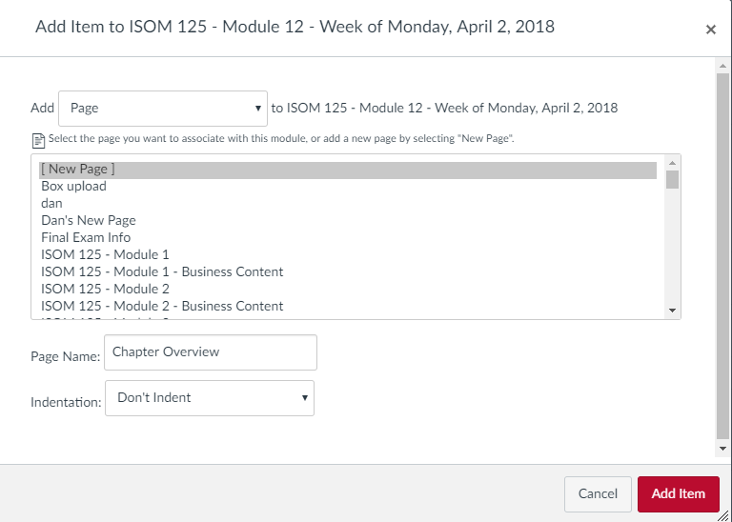

- Click on the new Page to add the Mediasite link
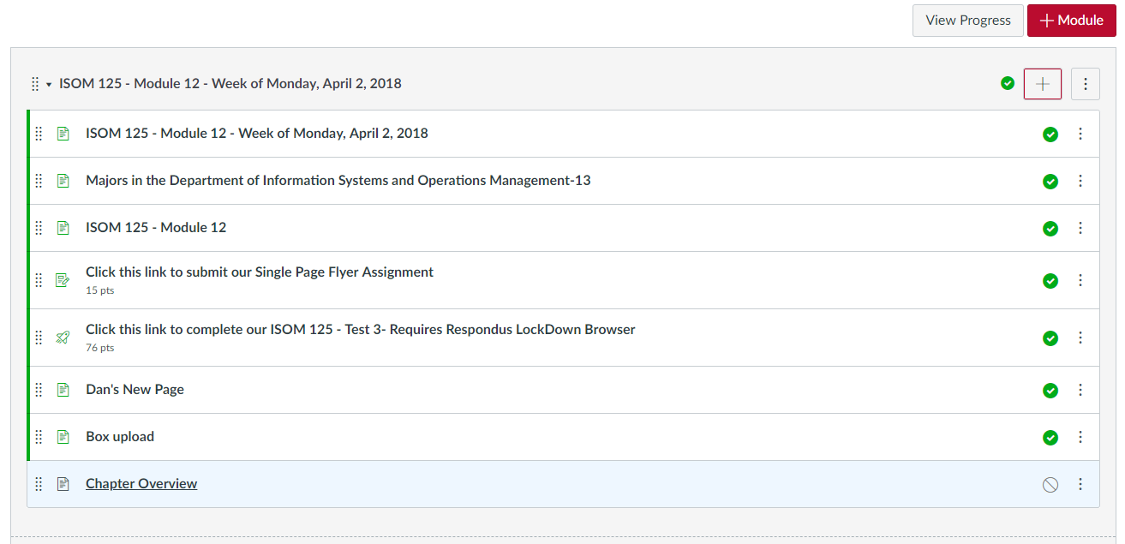

- Click the Edit button
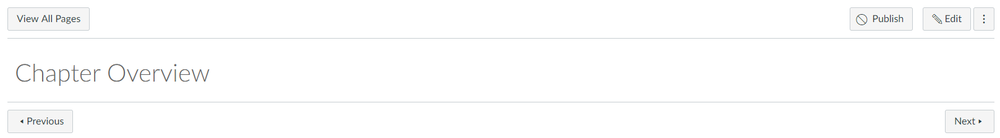

- Click the Apps button and click on Mediasite
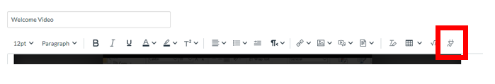
- Click on Mediasite
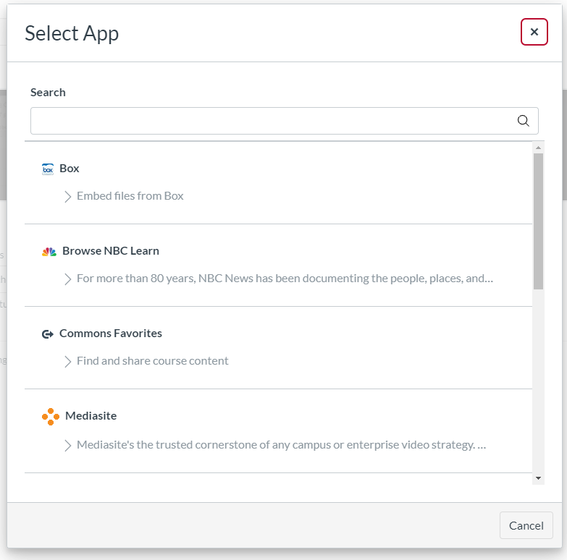

- Click Authorize
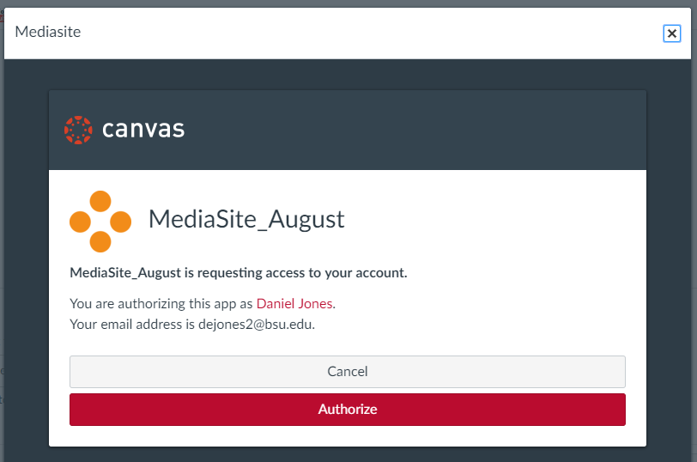

- Click Presentation
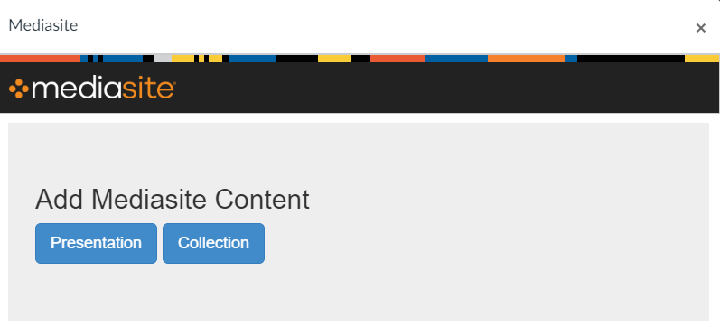

- Search for your video
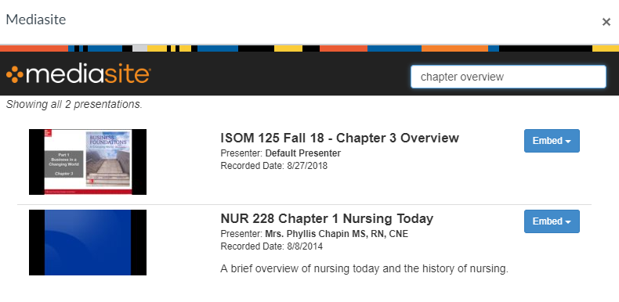

- Click the Embed button


- Select Player Only

- If you are ready for student to see the video click the Save and Publish button, otherwise click the Save button
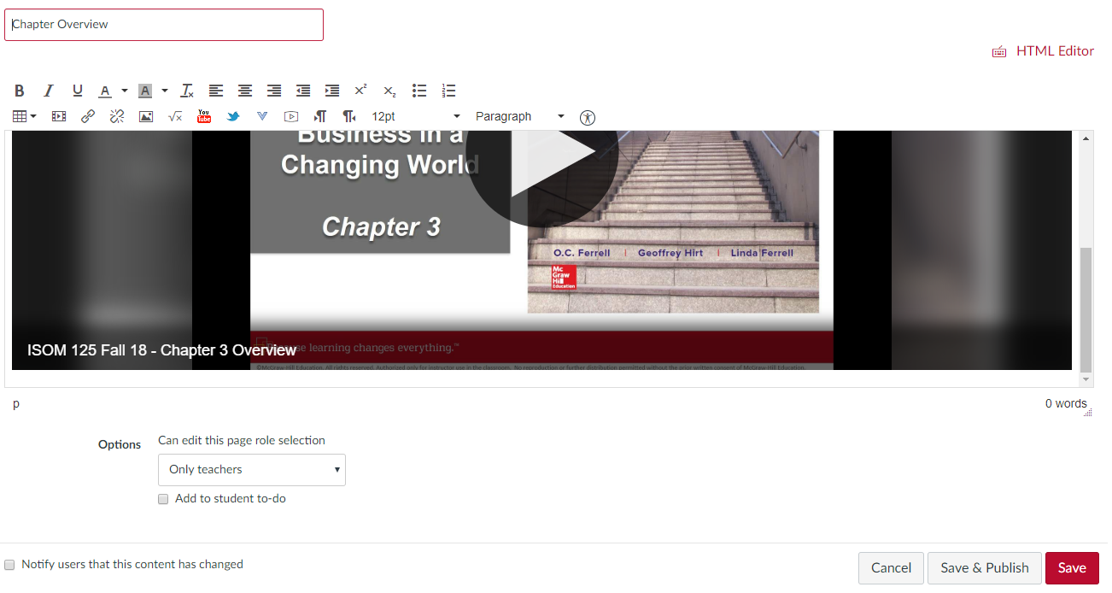

- Video is now embedded in Canvas and can be played directly in Canvas
