Ball State University
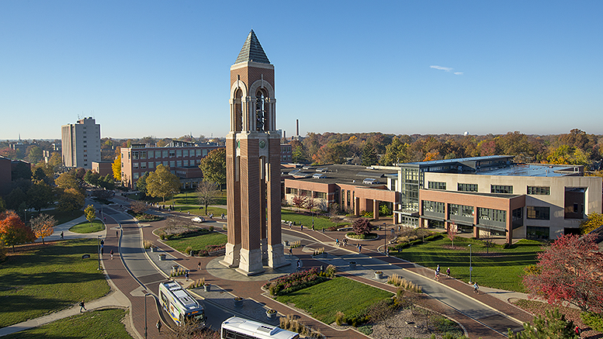
BALL STATE UNIVERSITY MISSION
We engage students in educational, research, and creative endeavors that empower our graduates to have fulfilling careers and meaningful lives enriched by lifelong learning and service, while we enhance the economic, environmental, and social vitality of our community, our state, and our world.
Facilities Planning and Management
Service Level Agreement
February 6, 2025

Table of Contents (Ctrl + Click to follow the link)
Mission Statement: 3
Organization Charts 3
Description of Services 3
Administration – Systems, Financial and Space Cost/Use 4
Architectural 7
Construction 14
Custodial Services 18
Engineering 21
Landscape Services 23
Operations and Maintenance 25
Outsourced service 27
Transportation 28
Bus Operations 34
General Repair and Rehabilitation 38
APPENDIX 41
Local, State and Federal Codes 41
Architectural and Engineering Standards 42

Facilities Planning and Management Mission Statement
Provide safe, well maintained, highly functional, aesthetically pleasing, and environmentally sustainable buildings and grounds which support the mission of Ball State University.

Organization Charts

FPM website: https://www.bsu.edu/about/administrativeoffices/facilities

Description of Services
- Daily Operations/Management
- Architectural/Planning/Design
- Engineering/Planning/Design
- Facilities Condition Assessment
- Construction Management
- Maintain all infrastructure systems/exterior lights
- Pest control
- Provide support to Auxiliaries, Athletics, Student Center
- Snow removal entire campus
- Maintain compliance with all building codes, local/state and federal/, ADA compliance
- Transportation/Shuttle Buses/Motor Pool
- Vehicle/bus/equipment repair
- Life safety systems
- Security systems
- Maintain all streets, parking lots/structures and sidewalks
- Real estate acquisition and management
- Central Plants (Boiler/Geothermal/High Voltage)
- Custodial Service all A/A Structures
- Energy Management/Sustainability
- Manage space use and studies
- Elevators/lifts
- Tree/Lawn/Landscape installation and care
- Maintain Campus Master Plan
- Interior and exterior signage
- Interior space design
- Furniture Purchases
- Waste Removal/Recycling
- General Repair and Rehabilitation

Administration – Systems, Financial and Space Cost/Use
Facilities Administration will provide excellent support to not only facilities, but to all of campus. Work will cross section with work across campus, preventative maintenance, payroll, purchasing, space, and custodial work.

Business hours for administrative support are 7:00 AM to 5:00 PM, Monday through Friday during winter hours, and 7:00 AM to 4:00 PM, Monday through Friday during summer hours.

Work Control
- Manage all incoming work requests via phone and WebTMA.
  - Create work orders and assign to the appropriate shop.
  - Radio in all urgent matters to the correct shop(s).
  - Ensure that all information is entered appropriately. Check FOAP for completeness and accuracy for billing, and review the type of charge to ensure accuracy of charge assignment.
  - Download work order purchase orders to apply.
  - Work control hours align with business hours. Calls outside of business hours will be routed to the Campus Operator. Calls should always be placed to 285-5081, except in the case of an emergency; in which case, the call should be placed to 285-1111 University Police, or 911.

- WebTMA
  - Create FOAPAL’s or suspend them as requested by BSU employees.
  - Create projects.
  - Manage all technical financial processes.
  - Create space records.
  - User support – Assist end users with questions.
  - Create and pull reports on cost by building, cost by area, chargebacks, preventative maintenance reports, and ad hoc reports as necessary.
  - Create preventative maintenance work orders.
  - Enter labor to the appropriate work order.
  - Run FUPLOAD monthly to create journal vouchers for chargebacks.
  - Provide work order detail to University clients as requested.
FPM Procurement
- Enter purchasing for all facilities-related items on campus.
- Identify sole source or purchasing choice.
- Assign FOAPAL’s.
- Connect work order to requisition when necessary, or charge to the appropriate building fund for direct charge.
- Create standing orders for urgent purchases that happen regularly for the University.
- Upload invoicing and enter receiving for payment.
- Reconcile all purchasing card charges for shops, garage, and custodial areas; connect work orders to charge back when necessary.
- Purchases for University include, but aren’t limited to:
  - Vehicles – Work trucks, plows, police cars, and motor pool vehicles
  - Buses – Shuttle, demand response, and road buses
  - Equipment
  - Repair parts
  - Maintenance supplies
  - Signage
  - Building materials
  - Custodial supplies
  - Furniture
  - Flooring
Inventory
- Manage all Facilities Inventory
  - Track inventory control and adjust as life cycles of equipment end and replacement is necessary.
  - Enter B450’s for accessed or aged equipment.
  - Work with shops to identify equipment that has been moved.
Square Footage/Space
- Track University square footage by building and usable space.
- Calculate price per square foot annually for state reporting.
- Schedule space for indoor/outdoor concourse, quad, arts terrace, etc.
Systems
- Manage software for facilities and end users.
- Troubleshoot issues and correct.
- Monitor and update software necessary for each area of facilities, including TMA Systems, Configura CET, DLT Solutions, AIA, SKM Systems, etc.
- Ensure electronic equipment is working appropriately for all areas of Facilities.
  - Update equipment.
- Manage iPads for buses.
- Maintain storage for scans of all blueprints.
Budget
- Develop the budget for the fiscal year, track and analyze expenditures.
  - Note trends, forecast, and review for future needs and changes based on the needs of the University.
  - Create and review operating and statistical reports.
  - Make changes to the budgeting process based on reports and upcoming needs.
  - Follow trends and anticipate campus developments.
- Track project expenses.
- Manage transportation/bus expenses, revenue, and maintenance.
- Estimate revenue and cost of projects.
- Track utility data for the University by meter, understand trends, and research changes.
- Identify cost of maintenance per building.
- Assign travel budget for professional development and certifications.
Expense Chargebacks*
- Chargeable - Upgrade, repair or maintenance of equipment, furnishings, and utilities peculiar to departments is considered a chargeable service. Event setups requiring overtime and work that falls outside the regular maintenance plan are also considered chargeable services. Chargeable services to be paid by the requesting department.
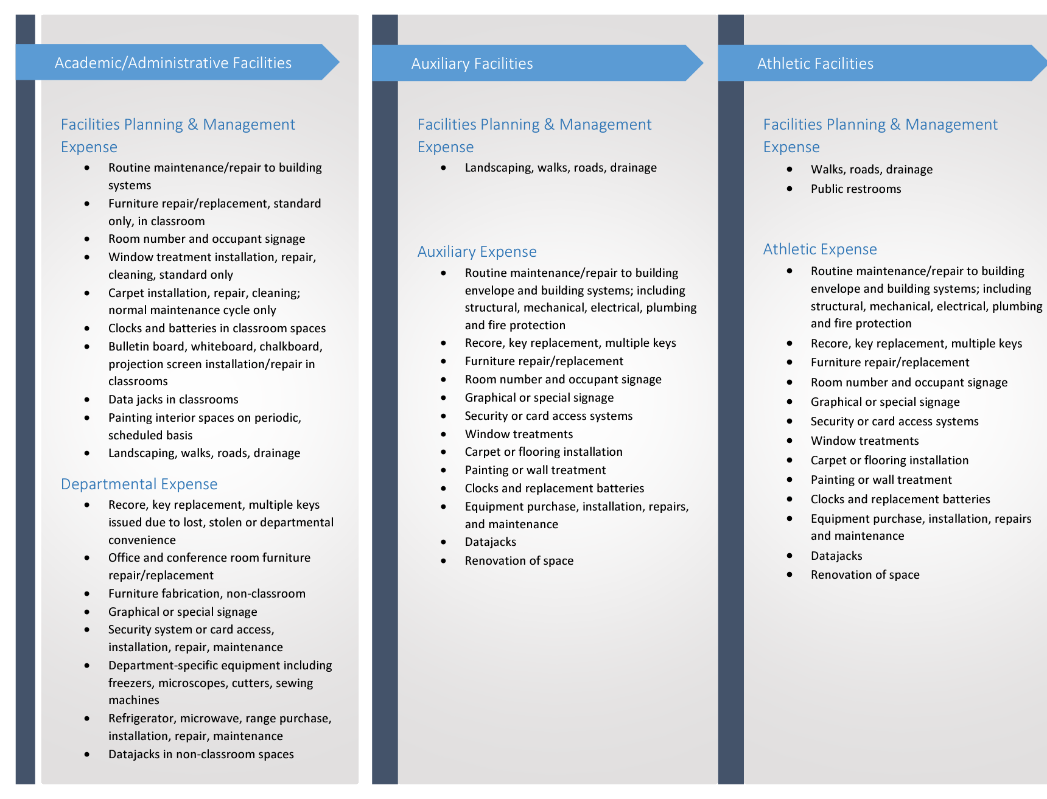
*List is not comprehensive. Changes can and will occur as fiscal needs require.
- Method of Charging - Chargeable services are processed monthly by Facilities Planning & Management through the University's accounting system. A copy of the charges is sent to the budgetary unit head immediately following the close of the monthly accounting cycle. Services are charged as they are incurred, which may result in some services being charged over a two- or three-month period.

For questions on chargeable services or individual charges, email facilities@bsu.edu.
HR/Payroll
- Track Hiring
  - Track Facilities positions and vacancies to ensure the campus has the required essential personnel.
  - Create position modifications and postings in TMS.
  - Share candidate pool with supervisors.
  - Enter request to hire and disposition other candidates.
- Process leave requests.
- Verify timecards and approve for pay.
- Track Leaves – FMLA, ESL, PTO, unpaid, loss time
- Uniform management

Architectural
Facilities Planning staff work normal business hours as listed under the “Administration” section. Exceptions occur when certain construction project schedules demand additional support outside these hours.

Facilities Planning staff includes architects, planners, and interior designers to provide support for planning and design of University facilities. The staff includes one or more licensed architect in the state of Indiana.

Staff members coordinate the planning, design, and development of future buildings and campus spaces, which includes space programing, budget formation, and project management duties.

On large capital projects, Facilities Planning team members manage the selection of architectural/engineering consultants, lead the design/planning process, oversee the project budget, and coordinate with other internal staff members including engineering and construction management personnel. Facilities Planning project managers are responsible for creating a planning committee comprised of building users and appropriate administrative units for each project, while directing this committee and the selected architect/engineering consultant throughout the planning and design process.

Facilities Planning staff provides necessary in-house architectural, interior design, and planning services required to complete smaller projects. Team members work with requestors to define the project scope and budget, create needed documents used for estimating and construction, facilitate the bidding and procurement process to third-party vendors and contractors, and assist in the selection of furniture and equipment. Our team also works directly with in-house shops to complete smaller projects which do not require outside third-party contractors.

General Services
- Construction architectural standards: Establish University standards for design, products, and materials to be used on campus construction projects.
- Construction documents: Work with the Finance office and Purchasing Services to establish standard front-end contract documents for bidding and quoting of construction projects.
- Furniture standards: Work in cooperation with Purchasing Services to establish standards that meet the long-term flexibility, durability, and aesthetic needs of the University. In cooperation with Purchasing Services Facilities Planning has worked to develop the furniture standards for use on campus. These standards are developed to establish long-term life and quality, ergonomic function, and esthetics.

Furniture Standards

- Code-compliance: Confirm each project is compliant with all Life Safety and Building Codes and meets standards set forth by the Americans with Disabilities Act (ADA) (See Appendix).

Project Planning
- Programming: Develop the project scope working with the end users and administrative units to determine the size and breakdown of primary spaces to be included in each project.
- Project Budget: Establish the estimated project cost based on the requested scope and specifications.
- Project Request forms
https://www.bsu.edu/-/media/www/departmentalcontent/facilities/pdf/prf.pdf
Capital Projects Committee
The role of the Capital Projects Priorities Committee (CPPC) is to provide broader campus input into decisions about capital project priorities and the biennial request to the State of Indiana for the funding of a capital project or projects. The time to make the biennial capital request to the State will be approximately July/August of the year prior to the legislative long session.

The Committee is made up of the following positions:
- Provost and Executive Vice President for Academic Affairs
- Chief Strategy Officer
- Vice President for Student Affairs
- Vice President for Governmental Relations
- Vice President for Business Affairs and Treasurer
- Associate Vice President of Budgets and Finance
- Associate Vice President of Facilities Planning and Management
Each biennium, the public universities in Indiana are allowed to request capital projects in the biennial budget request made to the State. The timing and form of that request is defined in the budget instructions issued every two years by the Indiana Commission for Higher Education and State Budget Agency. The instructions will allow each public university to request funding for a capital project or list of projects in priority order.

In deciding what capital project(s) should be a priority for the University, the CPPC identified ten broad criteria (some with subcomponents) as guidance for decision making. It should be noted that while some of the criteria are simple choices, many of the criteria do not lend themselves to simple evaluation or lie on a continuum scale that can be difficult to quantify or compare. Therefore, the recommendation of the CPPC must be under the totality of the circumstances and will require some nuance and judgment.

The criteria are as follows:
Campus Planning that Guides the Selection of Capital Projects
- Campus Strategic Plan
- Alignment with mission and goals of the University
- Academic Master/Program Plan
- Enrollment
- Pedagogy
- Accreditation
- Mission analysis
- Campus Master Plan
- Alignment with Strategic and Academic Plans
- Facility/Campus Condition Improvement Needs
  - Immediate needs/longer term plan
  - Cost/benefit of renovation/replacement
  - External Regulatory influences
  - Economic/environmental analysis
Factors that Influence the Selection of the Highest Priority Project
- Facility/Campus Condition Improvement Needs
- Funding sources
  - State funds
  - Philanthropic support
  - Internal funds
- Stakeholder Analysis
  - Political climate/appetite to fund
  - Condition of state budget/ability to fund
  - State workforce/ economic development needs/goals
  - Return on investment
  - Local community interests
- Long-term internal plans
  - Campus reserves (e.g., Housing & Dining, R&R reserves)
  - Planned replacement/renovations
- Campus climate
  - Faculty support
  - Student support
  - Internal working groups (e.g., Sustainability Working Group)
Architectural Planning and Design
- Large Capital projects: Develop Request for Qualifications (RFQ) establishing project criteria including scope of work, project budget, schedule, and relevant information needed to receive responses from perspective Architectural/Engineering (A/E) design teams.
Consultant Procedures and Design Guidelines
https://www.bsu.edu/-/media/www/departmentalcontent/facilities/pdf/bsu-consultant-procedures-and-guidelines-jan-10-2019.pdf?sc_lang=en
- Establish list of perspective A/E teams to request responses for each project RFQ.
- Review submitted RFQ responses to short-list teams for interview/selection.
- Assign a Project Manager (PM) to facilitate the planning and design process. The PM serves as the University contact between the building committee and A/E team and is responsible for monitoring project goals, budget conformance, schedule, and adherence to University design standards.

- Smaller projects (internal design): Assign Project Manager (PM) to work with Facilities Engineering and Construction staff and other University stakeholders to develop and refine the project scope, budget, and schedule.
  - Determine if project will be constructed with in-house Facilities shops or contracted to outside vendor.
  - Work with in-house shops to obtain estimates and schedule work to be completed by University construction personnel.
  - Create construction documents for bidding/quoting of projects through Purchasing Services when utilizing a third-party contractor.
  - Submit construction documents to State and City officials when required for appropriate permits and certifications. Review and recommend contractors.
  - Ensure design objectives are met.
  - Coordinate with Construction Management staff during construction process.

ADA Compliance, Life Safety and Building Code Review
Work to verify and maintain compliance with Federal, State and Local code standards. Work on identified ADA requests to design space for accommodations. Review design projects to identify possible ADA concerns/issues.

The Americans with Disabilities Act (ADA) mandates regulatory requirements while dictating the need for uniformity in building components and systems. The ADA’s implications require future construction to comply with the provisions, and any non-complying existing facility component when affected by renovations must be upgraded to meet the requirements of the act. In accordance with the ADA’s provisions, the University surveyed all public areas of campus in the early 1990s and identified specific needs and deficiencies to be addressed.

These include and have been addressed:
- Accessible parking
- Access top buildings from streets or parking areas
- Entrance to buildings with automatic door operators
- Vertical access within buildings with convenient controls
- Restroom accessibility, including fixtures
- Fire safety
- Hearing assistance in classrooms and at select telephones
- Directional signs
- ADA Guidelines
https://www.ada.gov/regs2010/2010ADAStandards/Guidance2010ADAstandards.htm

Campus Master Planning
- Work with Facilities Planning and Management staff along with third-party consultants in the creation and updating of the University Campus Master Plan.
- Review all future projects to confirm alignment with the Campus Master Plan intent and direction.

Campus Master Plan
https://www.bsu.edu/about/campus-master-plan

Bicycle Master Plan
- Create, manage, and maintain the Campus Bicycle Master Plan.

Real Estate Acquisition and Management
- Identify and facilitate all real estate acquisitions in selected target areas for current and future University needs.
- Work with University and community stakeholders on real estate issues.
- Direct third-party property management and leasing team members as required for off-campus University properties.
- Provide necessary asset management reporting for all University-owned and Foundation-owned real estate.
- Direct and maintain the land acquisition master plan

Space Planning
- Maintain inventory of campus-owned or managed space.
- Identify allocation of space and develop reports related to space usage.
- Maintain accurate floor plans and furniture plans for all University-owned buildings
Space Classification
Space Allotment Standard

Space Committee
Signage
- Develop and maintain standards for on-campus signage, working with University Marketing and Development on graphic components for compliance with University branding.
- Work includes interior room signage, building directory signs, interior wayfinding, exterior building and identification signs, department/college identification, and donor recognition.
Interior Signage Standards
https://www.bsu.edu/-/media/www/departmentalcontent/facilities/pdf/interior-building-signage.pdf

Project Design Committee
The Office of Business Affairs has historically been the primary party responsible for project decision making on campus, including decisions relating to architect selection, programmatic design, design concepts, and construction. To generate stronger campus engagement and broader review, a specially appointed committee will participate in the process through to its point of final Board approval.
The Project Design Committee (PDC) shall consist of five (5) members, all of whom must be Ball State University full-time professional staff or faculty, as follows:
- The Director of Facilities Planning, University Architect, will Chair the PDC
- One (1) member appointed by the Board of Trustees
- One (1) member appointed by the Office of the President
- One (1) member appointed by the Provost, which could be primarily from the College of
- Architecture and Planning
- One (1) member appointed by the Office of the VP of Business Affairs

Construction
Construction staff work normal business hours as listed under the “Administrative” section. Exceptions occur when certain construction project schedules demand additional support outside these hours.

The Construction Department staff includes leadership, management, support, and project administration for all University construction projects. Staff members provide document plan review, project management, inspections, budget and cost control, owner furnish planning and coordination, schedule adherence, safety review, record document compliance and archiving, warranty management, and building turn over to facility operations staff. Additionally, the Construction Department manages repair and restoration projects to building exteriors, parking lots, parking structures, and streets. Our goal is to create effective communication with internal and external customers to deliver sustainable projects while maintaining our institutional stewardship role.

On new capital and capital improvement projects, the construction department participates in the selection of architectural/engineering consultants, attends design/planning meetings, collaborates with the facilities planning staff on project budgets, engages with contractors and vendors to increase bidder interest (including MBE/WBE/VBE outreach), performs bid analysis and award recommendation, manages the architect/engineer and general contractor/construction manager contracts during construction, performs inspections, ensures schedule and budget compliance, reviews and processes invoices and pay applications, facilitates the closeout process, coordinates FPM shop participation for FFE items, coordinates occupant move-in schedule, and manages the building warranty during the warranty period.

On internal renovation projects (smaller projects that do not require outside third-party contractors) the construction department participates in the project review meeting, document plan review, schedule creation, scope review with BSU shops, customer connection, and budget management.

Document Plan Review
- Construction Standards: Manage and maintain University standards for division 01 General Requirements to be used on campus construction projects.
- Review design documents at Schematic Design (SD), Design Development (DD) and Construction Documents (CD) phases for logistics, feasibility, completeness, and constructability. The purpose is to identify design gaps and questions to ensure construction documents are complete, thereby reducing change orders.
- Apply design and quality lessons learned on past projects with the goal to eliminate repeat design and quality related issues.

Project Management
- Serve as the Owner’s Representative to assure the best interests of the University are upheld in achieving a finished product that complies with the contract documents with minimal disruptions to University activities.
- Management of design and professional services activities (contracts, insurance, design, schedule, etc.).
- Solicitation of Request for Qualifications (RFQ) or Request for Proposal (RFP) for specialty consultants and 3rd party testing agency services as required for construction.
- Identify and secure all required permits from federal, state and local government agencies.
- Development of construction phasing, logistics, and pedestrian/vehicular detours.
- Communicate project impact to the users of the facility, including issuance of campus notices when applicable.
- Coordinate project schedules with other projects within/adjacent to the facility.
- Coordinate contractor parking with Parking Services.
- Conduct pre-bid meeting for potential bidders.
- Review bids, recommend award of construction contract, and perform reference checks as needed.
- Conduct pre-construction meeting for awarded contractor and design team.
- Review all Requests for Information (RFI). Facilitate responses that are required by the Owner.
- Ensure that established University specifications and performance standards are met including construction schedule, cost, quality, and project safety requirements.
- Ensure that the contractor and design team are following BSU policies on tobacco, weapons, drones, and current COVID protocols.
- Participate in Owner Architect Contractor (OAC) meetings to ensure that project is on schedule, review cost items, RFIs, Architect’s Supplemental Instructions (ASI), coordination issues, etc., and review contractor-provided meeting notes post-meeting.
- Participate in Building Information Modeling (BIM) Coordination meetings to ensure contract requirements are being met and BSU standards are being satisfied.
- Ensure Facilities Planning and Management staff review of critical shop drawings and submittals for compliance with University standards.
- Coordinate all construction activities with occupants, contractor(s), and FPM Shops.
- Prepare and issue internal work orders for campus service providers.
- Prepare and issue purchase orders for external services.
- Monitor commissioning, testing, and balancing, and special testing activities to ensure compliance.
- Manage design-related issues (omissions, errors, or changes) during construction.
- Issue Stop Work orders to contractors as necessary. In the event of project changes, problems, or claims, take appropriate actions to resolve matters.
- Manage work provided by outside vendors and campus service providers.
- Repair & Rehabilitation projects: Prepare plans and work specifications through management of outside consultants.
- Manage contractor requests for substantial completion and final acceptance.
- Perform owner punch out.
- Verify punch list(s) complete.
- Arrange for department relocations and move-in activities as needed.
- Maintain all project information and documentation within department project management system.
- Manage timely project closeout.
- Identify and ensure collaboration with all project stakeholders during construction and warranty.
- Internal renovation projects: Perform shops roll out meeting and issue corresponding work orders.

Inspections
- Perform in-wall and above-ceiling rough-in inspections for building maintenance and accessibility.
- Inspect installed work for compliance with drawings and specifications.
- Inspect installed work for quality control.
- Manage third-party testing agency inspections. Ensure inspections are being sent to the construction team for action.
- Repair & Rehabilitation projects: Annually inspect and assess existing building facades, roofs, parking lots and roads for significant damage and normal wear and tear. Propose short-term and long-term repairs for capital asset budget management.
- Respond to major emergencies caused by building system failures, accidents or weather events and support operations staff and FPM shops.
- Respond to work order requests related to building leaks and/or damage, horizontal surface slip and trip hazards, and ADA-compliance issues.

Budget & Cost Control
- Review initial project budget and monitor during design phase.
- Manage project cost contingencies to be at (or under) established project budget. Manage budget approval and revisions as necessary.
- Be able to forecast final project cost during construction.
- Review and approve all requests for change orders for compliance with contract documents.
- Hold contractors and design professionals accountable for the requirements of their contracts as related to project cost and scope changes.
- Review and approve design professional and vendor payments.
- Review and approve progress payments of contractors for work-in-place and stored materials.

Owner Furnishing Planning and Coordination
- Identify all owner furnishings and equipment required for the project.
- Determine appropriate procurement methods in line with University procurement requirements.
- Schedule furniture move-in.
- Collaborate with customer and BSU Purchasing Services to develop faculty and staff move-in schedule.
- Ensure necessary asset management is being performed during departmental moves.

Schedule Adherence
- Review construction schedule for compliance with requirements.
- Participate in schedule update meetings, ensuring compliance with substantial completion date.
- Track material procurement to ensure schedule compliance.
- Create and manage schedule for all Owner-Furnished and/or Owner-Installed installations.
- Hold all project stakeholders accountable to the project schedule and issue notices when applicable.

Safety Review
- Ensure each project has a well thought out site-specific safety plan that complies with University operations and industry standards.
- Conduct construction safety inspections as necessary to identify potential hazards; take appropriate actions to increase safety.
- Monitor contractor safety practices.
- Ensure the safety of students, staff, faculty and pedestrians.

Record Document Compliance and Archiving
- Maintain contract document records during construction (both hard copy and electronic).
- Receive and review project as-built drawings and BIM model. Archive for future departmental use according to established standards.
- Receive and review project Operations & Maintenance Manuals and warranties. Archive for future departmental use according to established standards.
- Receive and distribute testing & balancing and commissioning reports to engineering staff. Archive for future departmental use according to established standards.
- Maintain database of project information.
- Retrieve project documents as requested by internal and external customers.
- Instruct others on how to use project archive software.
- Keep project archives organized.
- Manage printing services.

Warranty Management
- Manage warranty issues during specified post-construction warranty period.
- Coordinate one-year warranty walk and manage resolution of discovered warranty deficiencies.

Building Turn Over
- Ensure University operations staff have been trained on all building systems and equipment. Facilitate additional training if warranted.
- Review hard copy and electronic copy of as-built and Operations & Maintenance Manuals with operations personnel.
- Receive, verify, and distribute project required attic stock accordingly.
- Ensure preventative maintenance work orders are created for all building equipment.

Custodial Services
- 24/7 operation (except third shift on Friday and Saturday nights), primarily cleaning on 3rd shift and policing throughout the day and evening.
- All Academic/Administrative facilities, miscellaneous house locations, and parking structures
- Clean all public spaces, corridors, stairwells, elevators, classrooms, labs, conference rooms, lobbies, lounges, entrances, gyms, museums, kitchenettes.
- Clean all private spaces and offices.
- Clean and stock restrooms, stock hand sanitizer stations.
- Clean entire parking structures including garage space, stairwells, and elevators.
- Floor maintenance (carpet, tile, concrete, terrazzo, vinyl, wood, bamboo)
- Clean interior and exterior windows.
- Replace bad lamps in interior light fixtures and recycle old bulbs.
- Snow removal up to 10 feet from entrances
- Waste and recycling removal from interior spaces
- Flood, fire, vandalism, mold cleanup
- Lock and unlock entrances and classrooms as scheduled.
- Sanitize University facilities including using a UV light and disinfecting surfaces as needed.
- Area maintained: 3.6 million square feet of Academic/Administrative spaces —approximately 37,000 gross square feet (GSF) per custodian

Services and Frequencies
While some building and secured areas are cleaned by 1st and 2nd shift custodians, the bulk of FPM custodial services provided during the 3rd shift which is 10:30 PM to 7:00 AM Sunday through Thursday.

General Building Spaces
General building care consists of areas that are open to the public during business hours, but are not classrooms or restrooms.

Daily
- Security - Lock/unlock building entrances/rooms that are not automated.
- Clean entrances, walkways, and steps 10 feet out from building.
- Dock landing - Sweep/pick up trash.
- Clean entrance doors, entrance windows, and floor matting.
- Elevator car and tracks - Remove marks and sweep.
- Clean drinking fountains/bottle fill stations.
- Stairwells - Sweep/dust mop and clean railings.
- Clean entrances, vending areas, and lounges (furniture, floors, lights, walls, no vending equipment).
- Empty waste and recycling.
- Sanitize.

As Needed
- Interior windows - Cleaned or spot cleaned.
- Clean hallway doors.
- Replace bad incandescent, fluorescent, canister, track lights etc.
- Remove unapproved posters/flyers and marks from walls.

Annually
- Clean exterior windows.
- Wash walls.
- Clean light fixtures.
- Shampoo/extract carpets and entry runners.

Restroom Maintenance
Daily
- Empty landfill waste.
- Restock supplies.
- Clean and disinfect the following fixtures:
          - Soap dispensers
          - Hand towel dispensers
          - Feminine napkin dispensers
          - Lavatories
          - Urinals
          - Toilets
          - Toilet partitions
          - Door handles
  - Clean mirrors.
  - Sweep floors.
  - Mop floor.
  - Sanitize.

As needed
  - Wash walls.
  - Change lights.

Office Cleaning
Office cleaning is broken down into two different sections. The first section describes cleaning frequencies for shared spaces such as conference rooms and reception areas, and the second section describes cleaning frequencies for individual offices.

Department Office Reception areas, Conference Rooms, and Breakrooms
Daily
- Empty breakroom waste receptacles.

Weekly
- Empty landfill waste receptacles.
- Empty recycle receptacles.
- Dust mop.
- Vacuum.

As needed
- Extract carpet.
- Clean windows, blinds, and sills.
- Change lights.

Individual offices
Weekly
- Empty landfill waste.
- Empty recycle receptacles.
- Vacuum or dust mop.

As needed
- Dust mop.
- Extract carpet.
- Clean windows, blinds, and sills.
- Change lights.

Classroom and Lab Service
Daily
- Empty landfill waste receptacles.
- Empty recycle receptacles.
- Vacuum or dust mop.
- Chalkboards and whiteboards.
- Clean chairs and tables, tablet armchairs.
- Sanitize.

As needed
- Replace bad incandescent, fluorescent, canister, track lights etc.
- Clean windows, blinds, and sills.
- Spot clean carpet.
- Wet mop hard floors.
- Extract carpet.

Emergency Services
- Flood recovery
- Fire recovery
- Vandalism
- Snow removal: 10 feet out from building entrances at Academic/Administrative buildings

Mobile Custodial Services
While the bulk of detailed cleaning takes place overnight, FPM provides mobile custodial coverage throughout the day to address issues that arise during business hours.
- Restock restrooms.
- Respond to requests from personnel lock outs.
- Security/Weekend unlocking and locking of department requested buildings.
- Respond to custodial requests (clean up spills, change lights, etc.).
- Room locking and unlocking per departmental request.
- Provide custodial service for campus events (per requisition).

Miscellaneous Items Not Cleaned or repaired by Custodians:
- Personal carpets, rugs, or furniture
- Refrigerators, stoves, microwaves
- Electronics (i.e., computers, monitors, video display screens, etc.)
- Coffee machines
- Personal lamps or other personal appliances
- Dishes or utensils left in break rooms

The above work outline and frequency indicated is considered optimal, but some deviation from this schedule may be necessary during periods of personnel shortage, and emergencies such as flooding or snow removal.

Staffing Levels by Building, Shift, and Supervisor

Engineering
Engineering staff work normal business hours as listed under the “Administrative” section. Exceptions occur when certain construction project schedules demand additional support outside these hours.

Engineering staff includes two mechanical engineers to provide support to Facilities Planning, Operations, and Construction. The engineering staff includes at least one licensed professional engineer in the state of Indiana.

Staff members assist in equipment selections, building systems design and engineering consultant selections.

On large capital projects, Engineering provides University Standards to the consultants and reviews design documents to confirm adherence to these standards. During construction, Engineering participates in commissioning meetings and verifies final operations of the building systems.

Engineering provides in-house design services required to complete smaller projects in collaboration with Facilities Planning and the shops.

General Repair and Rehabilitation projects can be led by the Engineering team with the assistance of engineering consultants as required for complex electrical projects and may be bid and constructed by outside contractors.

General Services
- Define and maintain University standards on building utility equipment including air handling units, switchgear, and transformers.
- Collaborate with Electronic, Environmental and HVAC shops on the Building Management Systems used to control and monitor the campus facilities.
- Design small renovations and equipment replacement projects.
- Coordinate with outside engineers on design of new buildings and replacement and upgrades of existing equipment with a focus on upgrading product performance to reduce energy cost.
- Support the Facilities Planning Team in the design of campus projects.
- Direct and coordinate the mechanical, electrical, and plumbing development portions of all University construction projects; provide engineering design support for construction projects.
- Support the Construction Team with efforts to address installation concerns regarding mechanical, electrical, and plumbing systems.
- Support the Operations Team in the repair and upgrade of facility equipment.
- Participate in the transition of new building systems from contractor to the Operations Team.
- Collaborate with Environmental, Electrical, Electronic, Heat Plant, and HVAC shops to provide a functional building that maintains environmental conditions appropriate for the University use.
- Collaborate with High Voltage to maintain campus power substations and emergency power.
- Consult and review with Environmental Health and Safety (EHS) on modification made to campus facilities to ensure compliance with the applicable codes.
- Collaborate with the Operations Team and EHS to provide safe work environment (arc flash, tornado sirens, fire alarms).
- Correlate and maintain energy consumption data for all campus facilities; provide recommendations for energy conservation.
- Coordinate studies of campus mechanical, electrical, and plumbing systems; prepare long-and short-term recommendations for preventative maintenance repair and rehabilitation for University facilities.
* Use of outside consultants: At this time, the Engineering Department may use outside consultants for the electrical engineering component of construction projects designed by in-house architects. The decision will be made based on complexity, size, and specialty requirements of the project.
Landscape Services (exception: Athletic Fields serviced by Auxiliary Services)
Landscape Services normal business hours are 7:00 AM to 3:30 PM, Monday through Friday. Landscape Services will work outside business hours for such things as (but not limited to) snow removal, special projects, and/or during periods of heavy mowing.

Landscape Services currently has 27 employees, three supervisors, and the Director of Landscape Services. Of the 27 employees, six are considered skilled trades and are made up of arborists, pest control and equipment operators. Approximately 29 acres per employee are maintained, along with 25 to 30 miles of sidewalks and streets.

Landscape Services is responsible for all the campus landscape design, installation, and maintenance. This includes all new or renovated buildings along with regular renovation of existing landscape areas and lawns.

The campus is comprised of 788 acres. Of this acreage, 130 acres are mowed lawns. In addition, there are 8 acres in short grass prairie and 12 acres of eco-grass, which are mowed only once per month. Landscape Services also maintains several pieces of city property that border the campus.

Lawn areas are mowed once per week at a height of 3”. All grass clippings remain on the grass. This allows the clippings to break down and return nitrogen back to the lawn. Lawns are fertilized once per year using an organic fertilizer.

Currently, there are 60 annual beds scattered throughout campus. Most of these annual beds are located on the orientation walks given each summer. The annual beds are planted three times each year. Although this might seem excessive, it is based on maintenance requirements. Pansies are planted in the spring and fall. Pansies are cold-hardy and will take the cold snaps often experienced in the spring and fall seasons. Using pansies has eliminated the need for overtime to protect fewer hardy annuals. Annual beds are replanted in May with summer annuals. Pansies will not tolerate the summer heat. Annual beds are watered on a weekly basis, more often during the peak high temperatures of summer.

Landscape beds are mulched approximately every two to three years. Mulching is done for more than just appearances. Mulching helps retain moisture and reduce weed growth, equipment damage around trees, and the need to line trim; thereby reducing maintenance requirements.

In addition to plant installation and maintenance, Landscape Services installs pavers, retaining walls, irrigation, landscape lighting, drainage tile, asphalt repair; and cleans storm water catch basins, as well as supports other groups within FPM.

Campus streets are swept on a weekly basis from April to November, weather permitting. Street sweeping not only makes the campus more attractive but is required to keep the University compliant with state and federal storm water regulations.

Crews are assigned emptying exterior trash/recycling containers three times per week during the academic year and twice per week during breaks. They are also required to pick up trash/debris throughout campus every day. Crews collect pallets and coffee grounds from the campus dining areas on a weekly basis.

As essential personnel for the University, landscape employees work all hours of the day, seven days a week to clear the campus of snow and ice during the winter months. In addition to campus streets, Landscape Services also plows multiple city streets in and around the campus.

Snow and Ice Routes/Priority
Arborist Service
Landscape Services employs two arborists to maintain the campus forest.

The main pieces of large equipment used are a bucket truck, a chipper, and a stump grinder. The arborists are also equipped to climb trees (that are inaccessible) with the truck.

Ball State is designated a Class II arboretum.

Shade trees comprise 49% of the campus forest. Evergreens comprise 30% and ornamentals 21%.

The campus has approximately 7,064 trees. Seventy-five percent of the campus trees are 12” diameter or smaller; 17% fall within the size range of 12” to 18”; 4% range from 18” to 24”. The remaining 4% are more than 24” diameter. This is does not represent a well-balanced forest.
Spruce and Pine trees comprise the largest number of tree species on campus, followed by Maples, then Oaks.

Trees not only help shade the campus and make it more attractive, but contribute towards storm water management goals.

Landscape Services continues to work towards a 5-year pruning cycle for the entire campus; meaning every tree receives pruning or trimming every five years.

On average, 100 trees are removed a year, but this has increased during the current building trend. On average, 100-120 new trees are planted each year. This has also increased due to the construction activity on campus. New trees are trimmed or pruned prior to installation, if necessary. These two trends indicate why a large percentage of the campus forest is 12” diameter or less.

Tree debris is chipped and used as mulch. Larger pieces of wood are stockpiled, ground in a tub grinder, composted, and used as a mulch in outlying areas of campus.

The arborists are also responsible for cleaning gutters on numerous buildings and houses. This averages three times a year per building.

In addition, the arborists are responsible for hanging holiday lights and garlands.

Pest Control
Ball State employs two Pest Control Specialists. These individuals are certified by the State of Indiana in five specific categories.

- Turf
- Ornamentals
- Interior pests
- Mosquitoes
- Structural pests

In addition, a Landscape Services Supervisor and the Director of Landscape Services are also certified by the state in four of the above categories.

The Pest Control Specialists are responsible for all pest control activities on campus. This ranges from ants, bats, cockroaches, rodents, or anything else that flies, crawls, or is brought onto campus.

The Pest Control Specialists are responsible for monitoring pest issues in all kitchens, residence halls, offices, classrooms, mechanical rooms, and the campus landscape, among other locations. This includes treating all campus storm water catch basins and open water areas for mosquitoes.

The campus is managed using an Integrated Pest Management approach (IPM). IPM is a sustainable, science-based, decision-making process that combines biological, cultural, physical and chemical tools to identify, manage, and reduce risks from pests in a way that minimizes overall economic, health, and environmental risks (IPM Institute of North America).
IPM is a four-tiered implementation approach:
- Identify pests and monitor
- Set action thresholds
- Prevent
- Control

Key practices when using an IPM program are:
- Inspection and monitoring
- Sanitation, exclusion and pest-proofing
- Communication
- Biological, physical, and low-risk pesticides
- Recordkeeping

Pest control requests are done through the work order system. Requests may be completed on-line through the Facilities Planning & Management website or by calling Work Control. It is important for the specialists to know where and what the issue may be. This allows them to pinpoint the issue and address it expediently.

Operations and Maintenance
- Directs all skilled trades, electricians, carpenters, painters, electronics, plumbers, welders, HVAC, environmental control, and key control. Normal operating hours are 7:00 AM to 12:00 AM, Monday through Friday, unless otherwise noted below. The second shift, 3:30 PM to 12:00 AM, operates with a skeletal crew size. Refer to the “Administrative” section for reporting repair needs.

- Central plant operations:
  - Heat Plant: This operation works 24/7, including all holidays.
  - Geothermal operation: This is a 24/7 operation, but employees work only Monday through Friday, 7:00 AM to 3:30 PM, unless called upon.
  - High Voltage system: This is a 24/7 operation, but employees work only Monday through Friday, 7:00 AM to 3:30 PM, unless called upon.

- Manage small shops construction projects; typically, less than $50k
- Preventive maintenance activities
- Completes approximately 20,000 work orders annually
- Directs the maintenance of:
  - Fire alarm systems
  - Plumbing systems
  - Heating and cooling systems
  - Electrical systems
  - Electronic systems
  - Swimming pools
  - Fountains
  - Key control and electronic access systems
  - Security systems

Direct and manage all maintenance operation activities for all Academic and Administrative facilities, steam and condensate central plant, geothermal hot and chilled water central plants, all infrastructure systems and bus and fleet garage, and vehicle purchases.

Plan, direct and coordinate the operation, personnel, activities, and productivity of the skilled trade’s service staff, including corrective and preventive maintenance programs, schedules, methods, and procedures or work, material, and equipment requirements.

Plan, direct and coordinate the maintenance of all University infrastructure systems including interface with utility suppliers.

Coordinate work of contracted services and service personnel engaged in building systems service, and other related contractual services.

Monitor computerized work order system, workload, work order backlog, and scheduling issues.
Assist in development standards for vehicle purchases; develop specifications for vehicles and systems for replacement.

Direct the service garage, all bus services, vehicles services, garage parts inventory, and mechanic utilization.

Routine and non-routine maintenance
Public spaces will be maintained in good working condition, and no frequency is assigned to the needs.

In non-public spaces, office painting and carpet replacement are completed based on age and condition assessment by Operations staff and availability of funding. Determining who pays (FPM or DEPT) for the cost to repaint a space is based upon condition. (Damaged materials will be replaced as soon as possible.)

Departments will be responsible for the cost of painting under the following circumstances:
- Cosmetic painting
- Changing colors on occupant’s request
- Repairing damaged walls caused by the occupant or someone under their control
- Furniture painting or refinishing

Preventive Maintenance List

Outsourced Service
Certain services are outsourced based upon a more economical approach and availability of staffing, expertise, and inhouse equipment. Types of services include (but may not be limited to) the following. This list may change based upon budgets, and availability of staffing.
- Elevator service contract
- Waste removal entire campus
- Architectural/Engineering design services for projects with budgets above approx. $300K
- Major carpet cleaning
- Mowing of various remote/large locations
- Roof, masonry, window repairs
- Asphalt and concrete street repair/construction
- Parking lot repairs, parking structure repairs, and street striping (parking funds-supported)
- Construction projects above an average of $50K
- Auto body repairs
- Boiler inspections
- Cleaning of exterior windows
- Peak use vehicle rentals

Transportation
Our Mission
Fleet Services will utilize best practices to provide quality automotive vehicle services at the best possible value to support the educational mission of Ball State University. To fulfill this mission, we focus on delivering ease and convenience for your department’s business travel and transportation support services.

General Services
Staff Hours: 8:00 AM to 5:00 PM, Monday through Friday during the academic year. Office coverage will be 7:30 AM to 4:00 PM during summer hours.

The Motor Pool team will:
- Answer and direct phone calls in a polite and friendly manner.
- Welcome visitors in a warm and friendly manner and answer any questions visitors have.
- Respond to emails within a timely manner.
- Voicemails received will be responded to within 2 hours within the times stated. Any voicemails received outside of staff hours will be responded to within 2 hours of the start of the next working day.
Fleet Services
Provide both short and long-term vehicle rentals to all BSU departments. The quantity and types of vehicles available fluctuates daily. However, typical examples of available vehicles would include:
- Sedans – 4 to 5 passengers of varying types and sizes
- Minivans – 7 passengers, can be passenger or cargo
- Sport Utility vehicles – 4 to 5 passengers of varying types and sizes
- Passenger vans – 8 passengers, can be passenger or cargo
- Cargo van – 2 passengers
- ADA van – 3 passengers and 1 wheelchair, or 5 passengers
- As needed, arrange through Enterprise for specialized equipment and one way airport rental.
- As needed, arrange through a rental agency for 16- and 26-feet truck rental.

Vehicles are provided with a Wex Fleet card to use for outside purchases including fuel, roadside assistance, and service when off-campus. The Wex Connect app is available for customer convenience to assist in locating providers near your location.

Reservations are direct-billed through a monthly interdepartmental transfer. Fleet Commander reports are sent monthly to each department.

Loaner vehicles are provided for the long-term rental vehicle for servicing/repairs, when available.

Fleet Services serves as the Fleet Commander Help Desk for departments.
- Answer Fleet Commander-related inquiries.
- Provide guidance around the full range of services provided by Fleet Commander.
- Provide training over the phone, via video conferencing, or in-person when requested.

Motor Pool Reservation System
The Motor Pool Reservation System is utilized only by the travel delegate. The travel delegate is responsible for inputting all Fleet Commander profiles. All approved University drivers must have a Fleet Commander Profile to drive for University business. Fleet Commander is used to house all approved drivers as well as to request Motor Pool vehicle rentals.

To obtain driving privileges for an employee, please email our office with the employee’s name, BSU ID, and email address. Once we have received the request, we will begin the approval process by emailing the Motor Vehicle Record Consent Form. After reviewing the employee’s Motor Vehicle Record, the travel delegate will be notified of the employee’s driving status. If the driver is approved, the travel delegate will create their Fleet Commander profile.

How to Create a Fleet Commander Profile
- Log-in to Fleet Commander
- On the “Welcome” page, click on the link in the lower left “Sign Up Now!”
- Fill in the form completely with the Traveler/Driver information.
  - You will manage this profile for the traveler, so you will select the username and password. The Travel Delegate is the only person that has access to Fleet Commander.
- Be sure to fill out the 22 Digit FOAP field.
- Title: is Employee/Faculty/Staff/Director, etc.
- For “Delegate: Name, Phone, & Email” section(s) use your information.
- Once filled out completely, click on “Save Registration”.
- Once the profile is approved, you will receive an email.
- If needed, reservations can be made for the employee.

BSU Trip Calculator
https://www.bsu.edu/about/administrativeoffices/transportation/reserve-vehicle
You can also use our Trip Calculator to help determine your costs.

How to Become an Eligible Driver
Ball State University is pleased to offer University vehicles for specific University business. Consistent with the Ball State University Driving Privileges Policy, all Ball State University employees who intend to drive any University vehicle must first submit a “Motor Vehicle Record Check Consent Form”.

Your departments travel delegate can assist you with obtaining driving privileges. Upon receiving your request, we will email you the consent form for employees with an Indiana driver’s license. In the case of an employee with an out-of-state driver’s license, a current copy of the driver’s Motor Vehicle Record (MVR) from the state where the driver’s license is issued (that covers the previous 36 months) must be provided. The cost to obtain the out-of-state driving record is the responsibility of the driver. Once we have received the completed consent form or out-of-state MVR, we will determine if the minimum qualifications to drive a University vehicle (as defined by the Ball State University Driving Privileges Policy) are met. Once this determination has been completed, our office will notify you of the driver’s status.

If you need additional assistance, please contact our office at 765-285-1022.

Authorized Drivers
To be considered for approval to drive, the driver must meet the Ball State University Driving Privileges Policy qualifications and complete the Motor Record Consent Form. Annual Motor Vehicle Record reports will be completed for all Indiana-authorized drivers.

Fleet Services will annually review out-of-state Motor Vehicle Records for authorized drivers. Triannual Motor Vehicle Record reports will be completed for all authorized drivers on monitored or conditional status.

Fleet Services will serve as the authorized driver database Help Desk for departments.

In the event of an accident, a Certificate of Compliance will be submitted to the BMV for the authorized driver.

Driver Training is offered by request for 8-passenger vans, 16 and 26 ft. trucks and defensive driving.

Fuel
- Manage the automated fueling program and assign FOBs to all University vehicles and pins to authorized users.
- Import fuel, post and audit daily entries, identify discrepancies, and take corrective actions.
- Monitor fuel levels, collect bids, and order as needed.
- Maintain fuel pumps, equipment, and software for Transportation, North & South Grounds.
- Assist authorized drivers with fueling vehicle or equipment.
- Distribute WEX Fleet cards to authorized vehicles for outside purchases including fuel, roadside assistance, and service when off-campus.
  - Wex Connect app is available for customer convenience to assist in locating providers near your location.
  - Reconcile WEX Fleet card monthly statement.
- Fuel is direct-billed through a monthly interdepartmental transfer.
- Fuel reports are sent monthly to each department.

Wash Bay
- Pre- and post-inspections are completed prior to departure and upon return for Fleet Service vehicles.
- Fleet Service vehicles are sanitized, washed, cleaned, and fueled after each reservation.
- Departmental vehicles are sanitized, washed, cleaned, fueled, and waxed upon request.
- Buses are sanitized after the completion of their route.
- Buses are washed, cleaned, fueled, and waxed as needed.

Fleet Maintenance
- Provide professional maintenance services to end user, as transparently as possible.
- Develop and maintain Preventive Maintenance (PM) programs.
- Perform all safety-related repairs prior to returning vehicle/equipment to customer.
- Discuss and seek authorization from departments for high-cost repairs.
- Provide all title and licensing services for fleet vehicles and equipment.
- Maintain all fleet maintenance records.
- Analyze monthly report data and identify inaccuracies.
- Report all accident- and work-related damage.
- Fleet Maintenance monthly charges are direct billed through a monthly interdepartmental transfer.
- Management reports are sent monthly to each department.
- Distribute fleet insurance identification card annually.
- Manage all fleet vehicles and equipment from “cradle to grave”.
- Process Asset Disposal documents.

Motor Pool Overview
Motor Pool provides vehicles to authorized BSU-approved drivers for official campus business. Several different types of vehicles are available for rental. Motor Pool request are filled on a first come-first serve basis. If University Motor Pool vehicles are not available, we will do our best to work with our vendors to meet your needs.

Vehicle Rental Fleet Types
General Information
- Service and Stores Building, Door #5 (3401 N. Tillotson Avenue)
- Telephone (765) 285-1022
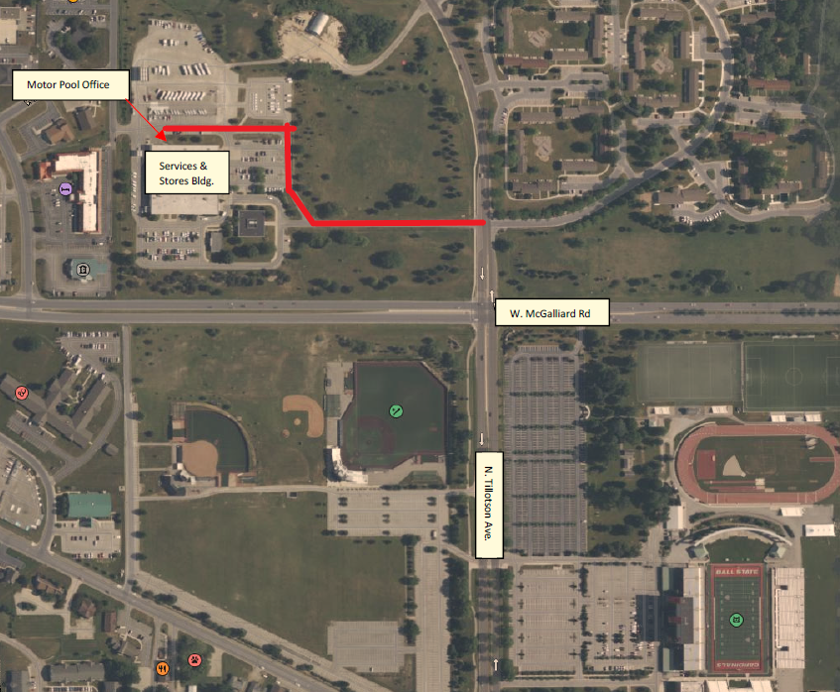
Hours
- 7:00 AM to 5:00 PM, Monday to Friday
- 7:00 AM to 4:00 PM, Monday to Friday - Summer
The Reservation Process
The process to rent a vehicle just takes a few steps:
- Contact your department’s travel delegate to start the reservation process.
- Chrome River pre-approval is required for your reservation prior to departure.
- You will receive a confirmation email with the reservation number and date/time of your scheduled pickup. If your departure is not during office hours, please contact our office to make other arrangements.
Picking up a Vehicle
- All Motor Pool vehicles are located at 3401 N. Tillotson Avenue, Door #5. For your convenience, we have two Motor Pool 5-minute parking spaces located just outside our office at Door #5.
- We will provide instructions if you need to pick up your vehicle outside our office hours.
- Please make sure that you are on time to pick up your vehicle. If you are running late or coming in early, please inform the Motor Pool Office so we can accommodate your and others’ vehicle needs.
- Users are required to show a valid driver’s license and sign for keys.
- When you pick up your vehicle, we will go over information about how to drop off your vehicle and the fueling procedures. We will also answer any questions you may have.
- Parking is available in the Motor Pool customer lot, and a BSU parking permit is needed. If you do not have a parking permit, please let us know at the time of pickup.
- Drivers are responsible for paying all parking fines, traffic violations, tolls, or fees. Any ticket or bill sent to the Motor Pool will be forwarded to your department.

Returning a Vehicle
- Please notify our office if your return time is significantly later than requested.
- You can return your vehicle to the Motor Pool parking lot anytime — 24 hours a day, seven days a week.
- Park the vehicle in the designated space in the Motor Pool lot; lock the vehicle’s doors; and return keys, credit card, and paperwork to the office or key drop box.
- Record return date, time and mileage on Motor Pool Travel Sheet and place fuel receipts in the key case.
- If there are any vehicle conditions (for mechanical issues, damage, etc.) to report and the office is not open, these can be made on the Motor Pool Travel Sheet or by email.
- The Motor Pool is not responsible for items left in vehicles.

Changing or Cancelling a Reservation
- Any changes or cancellations can be requested through your travel delegate.
- All cancellations must be made at least 24 hours prior to the scheduled pick-up time to avoid incurring a late cancellation fee.

Fuel Services
A 24-hour fueling station for University vehicles is located on the northwest side of the Transportation department. A University Fuel ProKey must be used to get fuel. Motor Pool assigns a ProKey to each University vehicle. Each department can request approved drivers to be assigned a user pin number to access fuel from the University Fuel Master system. Motor Pool staff are available from 6:00 AM to 11:00 PM to assist staff with fueling. Fuel purchases are billed monthly.

WEX Fuel Card Program
The University WEX Card (issued by WEX Inc.) is a credit card which acts as a fuel procurement tool for off-site campus fueling. The University’s WEX Card Fuel Program is designed to conveniently purchase fuel off-site directly from any major U.S. gas station for authorized business purposes.The WEX Card includes roadside assistance and maintenance when you are traveling outside of the area. Use of the WEX Care for personal purchases is strictly prohibited.

If you need additional assistance, please contact our office at (765) 285-1022.

Bus Operations

On-Campus Shuttle Bus Service

Fall and Spring Semesters:

Red Loop - South commuter lot through campus to Anthony Apartments and Oakwood Building
Monday through Thursday, 7:15 AM to 7:00 PM
Fridays, 7:15 AM to 4:00 PM

Green Loop - South commuter lot through campus to Anthony Apartments, Scheumann Stadium, Scheidler Apartments, and Baseball Parking Lot
Monday through Thursday, 7:15 AM to 11:00 PM
Fridays, 7:15 AM to 8:00 PM
Sundays, 5:00 PM to 11:00 PM

PURPLE Loop - South commuter lot to IU Health Ball Memorial Hospital/Glick, Cooper Science, Studebaker, New York Parking Garage, and Foundational Sciences Building
Monday through Thursday, 7:15 AM to 11:00 PM
Fridays, 7:15 AM to 8:00 PM
Sundays, 5:00 PM to 11:00 PM

Blue Loop - East main campus service to Linden Street
Monday through Thursday, 7:15 AM to 9:30 PM
Fridays, 7:15 AM to 8:00 PM

*Bus routes are subject to change based on need, funding, and availability.

On-Campus Demand-Response Service
This service is provided for persons requiring mobility assistance as determined by the Office of Disability Services.

Fall and Spring Semesters:
- Monday through Thursday, 7:15 AM to 11:00 PM
- Fridays, 7:15 AM to 8:00 PM
- Dispatch can be reached at (765) 285-9045 during operating hours.
- Available only at established pick-up/drop-off locations.

Charter Bus Service
Scheduled services are available to University departments for official events (field trips, athletic events, and other University-related activities).

- Available year-round, day or night
- 250-mile service radius from campus. University Buses do not travel to Chicago.
  - Internal rates of either $50/hour (3-hour minimum) or $2.75/mile, whichever is greater.*
- Charter Bus requisition form can be found at: https://www.bsu.edu/about/administrativeoffices/transportation/bus-shuttle-services/charter-buses

Airport Shuttle Service
Scheduled services are available for students and staff to and from the Indianapolis Airport at the beginning of each semester and during holiday and semester breaks. Reservations must be made 48 hours in advance.

- Pre-determined dates and times available for reservation at: https://www.bsu.edu/about/administrativeoffices/transportation/bus-shuttle-services/airport-shuttle
- $55 per person, one-way (non-refundable)*
- Available only at established pick-up/drop-off locations.

*Price changes can occur to meet fiscal need.

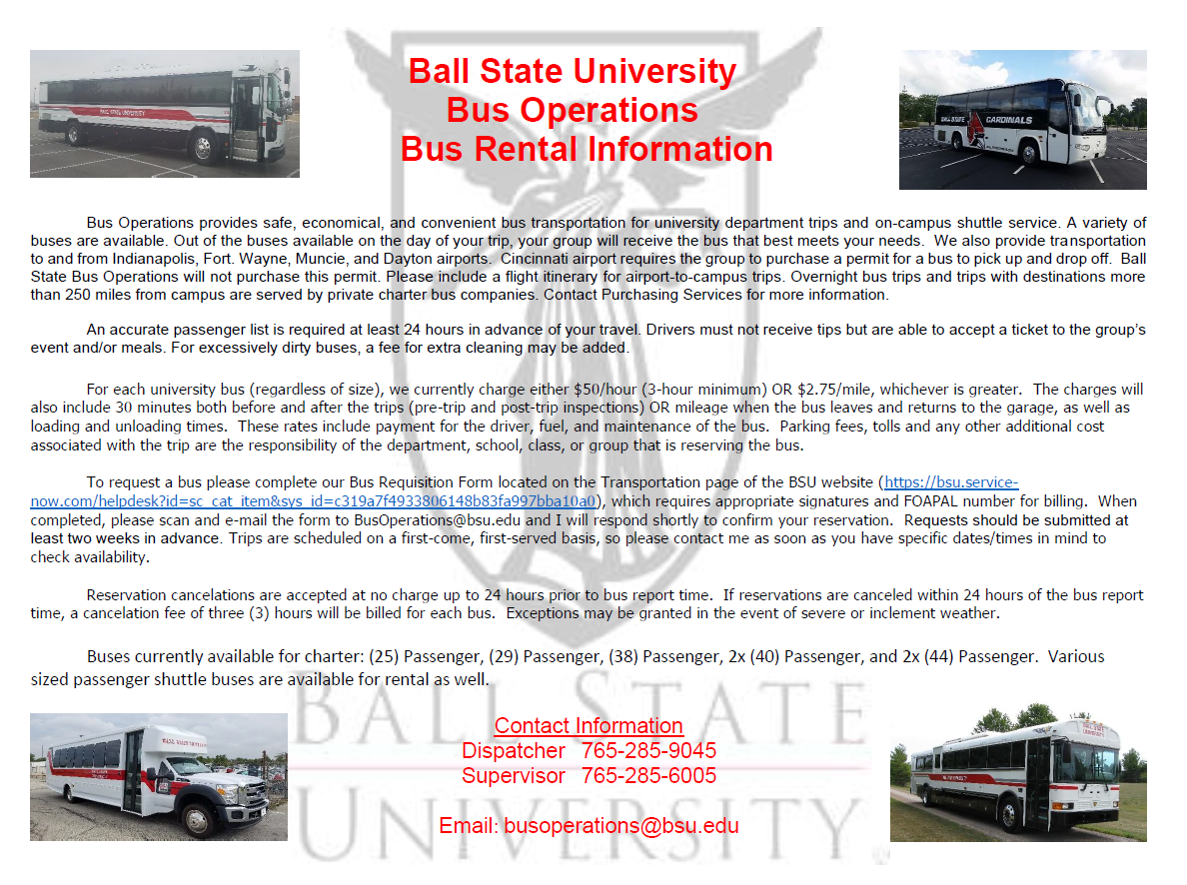

General Repair and Rehabilitation
Ball State University’s 10-year Renewal and Rehabilitation plan for Academic/Administrative facilities and infrastructure systems compiles actual project needs and life cycle estimates in the following categories. The actual expenditures are dependent upon appropriations approved by the General Assembly and are not funded from the FPM annual budget. As the R&R budget permits, these contents and/or systems are upgraded or replaced during routine maintenance. The life-cycle approach to certain finishes and/or components are listed in the PDF link below titled “Life Cycles”.

Facilities
- Roof Replacement
- Code Correction
- Interior Renovation
- Exterior Renovation
- Health and Safety
- Major Renovation
- Building Mechanical Systems
- Building Electrical Systems

Infrastructure/Utilities
- Telecommunication
- Electrical
- Water/Sewage
- Steam/Chilled Water/Tunnel
- Sidewalk/Street

The University’s renewal plan combines a facility and infrastructure component life-cycle process, together with physical condition surveys of the facilities and infrastructure systems, to plan and generate a list of improvement projects. Projects are undertaken in order of importance based on an established priority schedule. The following overview will explain the Ball State University process.

Overview
The rapid growth of University facilities in the 1950s, 1960s and 1970s has resulted in an ever-increasing obligation for repair and rehabilitation funds. Aging facilities and infrastructure systems, normal obsolescence, changing educational needs, enhanced teaching technology, and new environmental and safety standards are a few of the factors that have created the need for greater expenditures.

Facilities and infrastructure system renewal is an important goal in support of the University’s mission of becoming a premier teaching institution. Our goal in supporting this mission is to provide the best possible teaching and learning environment. The condition and appearance of the facilities also provide the important first impression for new students and their parents.

Ball State’s process for evaluating renewal projects to be considered for General Repair and Rehabilitation appropriations combines two approaches. A long-range forecast estimates facility and infrastructure component obsolescence (life-cycle) and identifies the renewal costs. This approach is then used as the basis for a physical condition survey to identify actual repair needs.

To meet facilities and infrastructure system renewal goals, both long-range planning and the prudent use of current funds are necessary to be successful. The development of renewal project alternatives involves strategic planning to ensure that facilities and infrastructure systems are renewed on a “least cost” basis. Repairs to older facilities and infrastructure systems must be made now to prevent an even greater obligation in the future.

Project Identification Procedure
Facilities and Infrastructure Component Renewal (Life-Cycle)
The premise of the facility and infrastructure component life-cycle renewal process is that facilities and infrastructure systems are comprised of a set of components or subsystems that wear out on a relative predictable time schedule. Life-cycles were determined for approximately 40 components based on industry sources, engineering publications, and the experience of the University’s facilities personnel. Once compiled, this information is used to indicate a reasonable expectation of component failure timetable.

List of Life Cycle Components
The Physical Survey
The actual site inspection of the facility and infrastructure systems is an important procedure in determining component conditions and replacement needs. When used with the component life-cycle information, it becomes an even more effective procedure. With many facilities and infrastructure systems to analyze, this combined information facilitates a more efficient use of inspection time. The site inspection is an ongoing process that is driven by feedback from facilities maintenance personnel.
Priority Schedule
When the actual on-site physical evaluations are complete, the information is used to package specific projects. The projects are then prioritized. Those lower-priority projects that exceed available funding will, of necessity, be deferred to the next biennium. The following factors, listed in descending order of priority, are used to prioritize the project list:

- Renewal project to correct deterioration or damage to a facility or infrastructure system which has a negative impact on instruction (such as in a classroom or laboratory)
- Renewal project to correct deterioration or damage to a facility or infrastructure system which has a negative impact on spaces other than instructional areas (such as administrative offices)
- Improvements needed to meet code compliance and health and safety standards
- A repair of a nature which has a savings on operating costs
- Current problems, which, when correction is delayed, will cause other damage of a serious nature
- Repair and/or replacement projects to be completed at a reduced cost when undertaken concurrently with other related higher priority projects
- Replacement of an obsolete system or component which is beyond economical repair
- Improvements to components due to advancing technology
- Renovation projects aimed at upgrading existing facilities and infrastructure systems to protect the value of the asset

Conclusion
Ball State will continue to plan future repair and renewal needs utilizing a process that provides a solid base for long-range planning. Using this process, the greatest return for funds invested in the renewal of University facilities and infrastructure systems (within established guidelines for the use of General Repair and Rehabilitation funds) will be provided.

APPENDIX
Links and PDF documents: These links serve to demonstrate that which FPM manages, maintains, and establish as design standards for all structures, infrastructure, and facilities, and codes to which we must comply.

All campus structure address and original cost

Infrastructure Systems Supported by FPM

Elevators

Emergency Generators

All campus structure current replacement cost 2021

Local, State and Federal Codes
The following codes, regulations are monitored, and managed for adherence by FPM for all campus facilities. FPM has several licensed architects, engineers, and other certified professionals who are responsible for understanding and adhering to these codes for all Ball State facilities.

- Boiler Permit 326 IAC 2 and 40 CFR Part 70 appendix A IDEM Stack inspections IC 13-14-2-2
- National Pollutant Discharge Elimination System NPDES
- NPDES Federal Water Pollution IC 13-15 Campus Wide; MS4 status
- NPDES 327 IAC 15.5 Rule 5 for Construction Operations over 1 acre
- BMV CDLs requirements
- Indiana Pipeline Safety Act of 1971 (IC 1971 8-1-22.5) for natural gas pipeline corrosion protection
- Clean Air Act: Refrigerant use, training, and certification
- Arc Flash NEC 2002 and NFPA 70 E
- IDNR IC 15-16-5 Pesticide use and application
- Material Safety Data Sheets
- Indiana Department of Health 675 IAC 20-1.1 Swimming Pool Code
- Indiana Department of Health: Virginia Graham/Baker Pool Safety Act
- Indiana Pipeline Safety Act IC 1971 8-1-22.5 Underground natural gas lines corrosion protection
- Occupation and Safety Health Act (OSHA and IOSHA) Employee safety protection
- Indiana Energy Conservation Code (IECC), (675 IAC 19-3)
- ASHRAE 90.1 (2007) Indiana Energy Code
- Elevator Codes: AMSE 17 and 18
- State and local design review
- Local Building Inspection
- IDEM Underground Storage Tanks Permits
- Indiana Pressure Vessel Fees, Permits and Inspections; IC 22-15-6
- American with Disabilities Act (ADA)
- Domestic water back flow device inspections
- Indiana Building Code (IBC)
- Indiana Fire Code (IFC)
- NFPA with Indiana amendments; Fire Protection Systems
- NFPA 101 Life Safety
- IBC Chapter 11, 675 IAC 13-2.5-12 accessibility
- Indiana Plumbing Code (IPC), and Uniform Plumbing Code (675 IAC 16-1.3)
- Indiana Electrical Code (IEC)
- NFPA 70 (675 IAC 17-1.8) Electrical, fire alarm systems
- Indiana Mechanical Code (IMC)
- International Mechanical Code (675 IAC 18-1.5)

Architectural Standards

Demonstration and Training of MEP Systems
https://www.bsu.edu/-/media/www/departmentalcontent/facilities/pdf/mechanical-guidlines/01-7900-demonstration-and-training-of-mep-systems.pdf?sc_lang=en

MEP Design Development Review Checklist
https://www.bsu.edu/about/administrativeoffices/facilities/facilitiesplanning/outsidecontractors/mechanical-standards-and-guidelines

MEP and FP Construction Inspection – Master Checklist
https://www.bsu.edu/-/media/www/departmentalcontent/facilities/pdf/mep--fp-inspection-checklist.pdf?sc_lang=en

Electrical Standards and Guidelines
https://www.bsu.edu/about/administrativeoffices/facilities/facilitiesplanning/outsidecontractors/electrical-standards

Key Policy

