FRANK FELSENSTEIN
felsenstein@bsu.edu
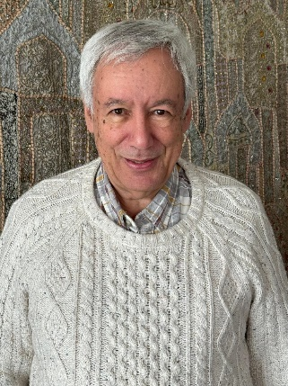
EDUCATION

1971 Ph.D. 1966 B.A. (Hons.) in English, University of Leeds: doctoral thesis on Tobias Smollett

ACADEMIC EXPERIENCE 2002-2017 Reed D. Voran Honors Distinguished Professor of Humanities, Ball State University, Muncie, Indiana: Emeritus 2017- ; 1998-2002 Professor of Humanities and Founding Director, Jay and Jeanie Schottenstein Honors Program, Yeshiva College, New York; also Visiting Professor of Book History, Caspersen School of Graduate Studies, Drew University, NJ; 1971-1998 Lecturer/ Senior Lecturer/ Reader in Eighteenth-Century Studies, University of Leeds, U.K.; 1989-1990 Visiting Professor, Vanderbilt University; 1968-1970 Assistant Lecturer in English, Université de Genève, Switzerland

PUBLICATIONS: Books (selection)

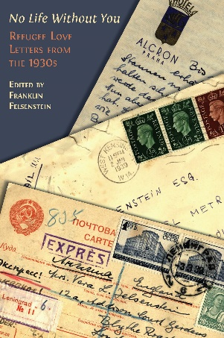

“No Life Without You”: Refugee Love Letters from the 1930s; Open Book Publishers, Cambridge, England, 2024, accessible via https://www.openbookpublishers.com/books/10.11647/obp.0334 in both print and downloadable open access editions.

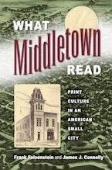

What Middletown Read: Print Culture in an American Small City; joint authorship with Dr. James J. Connolly; University of Massachusetts Press; xvi, 304 pp., 2015; hard cover and paperback editions

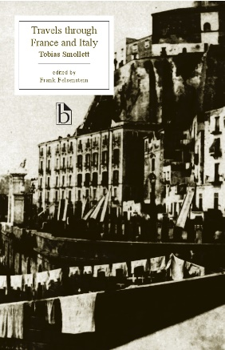

Tobias Smollett, Travels through France and Italy, new and updated edition with extensive contextual appendices, for Broadview Press, Canada, 2011, 486 pp., to be available on-line 2024 (also Oxford University Press editions, 1979 and 1981)

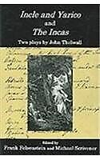

Incle and Yarico and The Incas: Two Plays by John Thelwall, Edited by Frank Felsenstein and Michael Scrivener, Fairleigh Dickinson University Press, 2006, 168 pp.; hard cover

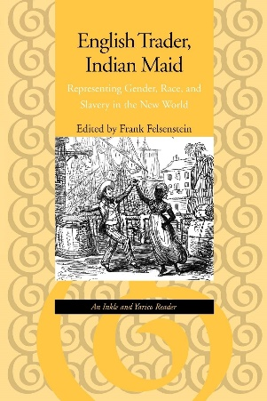

English Trader, Indian Maid: Representing Gender, Race, and Slavery in the New World -- An Inkle and Yarico Reader, Johns Hopkins University Press, 1999, 332 pp.: hard cover and paperback editions

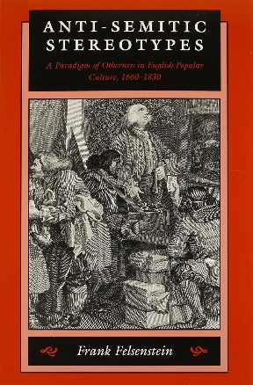

Anti-Semitic Stereotypes: A Paradigm of Otherness in English Popular Culture, 1660-1830, Johns Hopkins University Press, 1995, 376 pp.: hard cover; paperback (revised), spring 1999

Contribution to Books and On-Line Presence (selection)

“Was Smollett into Body-Snatching?: Deciphering a Hitherto Unpublished Letter”, in Smollett at 300, ed. Richard Jones, pp. 21-38 (Clemson and Liverpool University Presses, 2023)
“Truncated Memories: Berlin and Frankfurt in the Afterlives of Two Jewish Refugee Women,” Times of Israel, 27 September 2017, at https://blogs.timesofisrael.com/truncated-memories-berlin-and-frankfurt-in-the-afterlives-of-two-jewish-refugee-women

Print Culture Histories Beyond the Metropolis; jointly edited volume with four others (University of Toronto Press, 2016)

‘“If you tickle us, do we not laugh?”: Stereotypes of Jews in English Graphic Humor’: Ch. 3 [pp. 49-75], in No Laughing Matter: Visual Humor in Ideas of Race, Nationality and Ethnicity, ed. Angela Rosenthal et al, (UP of New England, 2015)

Joint authorship with three others, “Colman’s Inkle and Yarico: Four Critical Perspectives,” The Oxford Handbook of the Georgian Theatre, 1737-1832, ed. Julia Swindells and David Taylor (Oxford University Press, 2014), 688-705

What Middletown Read – Collaborative project based on nineteenth-century ledgers in Muncie Public Library; launched March 2011; see www.bsu.edu/libraries/wmr. In 2015, What Middletown Read was selected as one of the fifty prime projects (out of 63,000) funded by the National Endowment for the Humanities; see http://50.neh.gov/projects

Recent Presentations (representative selection)

“An Ekphrastic Interlude: From Mainland Liberty to Island Enslavement in the Story of Inkle and Yarico” (Columbia University Seminar on Abolitionism and the Arts, May 2023 (https://abolitionism.universityseminars.columbia.edu/home)
“From Gutenberg to Google: Teaching Book History from the Bracken Library”: Annual Kirkham Lecture: Friends of the Bracken Library, Ball State University, Muncie, Indiana, May 2023. A curated exhibition of artifacts accompanied the talk.
“No Life Without You”: Annual Yom Hashoah (Holocaust Memorial) Lecture, Sinai Synagogue, Chicago, April 2023
“No Peaceful Burial Place: Encountering Body Snatching and the Early Teaching of Practical Anatomy from a Letter of Tobias Smollett to Dr. William Hunter”: International Museum of Surgical Science, Chicago, March 2023

“Jews in English Caricature” and “World War 2, Jews, and Cartoons,” adult education, Sinai Synagogue, Chicago, March 2023

RESEARCH AND WORK IN PROGRESS

Rowlandson’s Jews: Visual and Textual Representations of Jews and Judaism in English Popular Culture at the Turn of the Nineteenth Century

